MIT Art, Design and Technology University MIT School of Computing, Pune

Department of Information Technology

SUBJECT – FULL STACK FRONT END DEVELOPMENT COURSE CODE – 23IT3001

Class – T.Y. SMAD

Name of Student

Sanskrti Singh – ADT23SOCB1557

Under the Guidance of Prof. Rohini Bhosale

T.Y. 2025-2026 (SEM – V)

COURSE STRUCTURE

Full Stack Front-End Development

SEMESTER – V
Course Code: |  | 23IT3001 | Course Credits: | 04
Teaching Hours / Week (L:T:P): |  | 2:0:4 | CA Marks: | 50
Total Number of Teaching Hours: |  | 60 | END-SEM Marks: | 50

Course Prerequisites: Web Programming

Course Description:

This course equips students with skills in responsive web design using Bootstrap and Flexbox, and dynamic interface development using React. It emphasizes component-based architecture, state management, and interactive user experiences for modern web applications.

Course Learning Objectives: This course will enable the students to:

Demonstrate the fundamental concepts of responsive web design with grid structures and Bootstrap components.

Design and build clear, easy-to-use web forms using Bootstrap and Flexbox to improve user experience and accessibility.

Set up and use a React development environment, showing skill in basic project setup, JSX, and building modular apps.

Develop proficiency in constructing modular and reusable React components using JSX and props.

Develop the capability to execute interactivity and state management in React applications through the utilization of Hooks and event handling.

Course Outcome: The students will be able to:

Illustrate responsive design principles using Bootstrap components and grid systems for adaptive web interfaces.

Design accessible, structured web forms using Bootstrap utilities and Flexbox for intuitive user experiences.

Configure and deploy a React development environment to scaffold and run modular front-end applications.

Analyze and construct reusable React components by leveraging JSX and data binding through props.

Create interactive React applications using Hooks and event-handling techniques for dynamic state management.
UNIT – I | Responsive Interfaces with Bootstrap Components |  |  |  | 9 Hours

Module 1: Introduction to Media Queries, Responsive Web Design Using Media Queries, Syntax, Uses of Media Queries, Benefits of Responsive Design, Elements of a Responsive Design, Working of Responsive Design

Module 2: Introduction to Bootstrap: Introduction to Bootstrap: Bootstrap Concept, Uses of Bootstrap, Bootstrap library source, Bootstrap Basics- container, jumbotron, page header, buttons, tables;

Module 3: Bootstrap Grid System
Pedagogy | ICT Teaching / PowerPoint Presentation and Videos
Pedagogy | Self-study / Do it yourself /
Pedagogy | Experiential Learning Topics:
Pedagogy | Case Study / PBL - Project Based Learning
UNIT – II | Form Design and Layouts using Bootstrap and Flexbox |  |  |  | 9 Hours

Module 1: Bootstrap Forms- stacked form, textarea, form row/grid (inline forms), form control size, color picker, select menu, select menu size, data list, checkboxes, radio buttons, toggle switches;

Module 2: Bootstrap Flexbox- horizontal direction, vertical direction.
Pedagogy | ICT Teaching / PowerPoint Presentation and Videos
Pedagogy | Self-study / Do it yourself
Pedagogy | Experiential Learning Topics:
Pedagogy | Case Study / PBL - Project Based Learning
UNIT – III | Introduction to React and Development Environment Setup |  |  |  | 9 Hours

Module 1 - Introduction to React: What is React? Advantages of React for dynamic web and mobile applications;

Module 2 - Environment Setup: Installing Node.js and npm, Creating a React project using create-react-app; Overview of folder structure and development tools; Running the development server and understanding hot reloading;

Module 3- Writing Your First React Application: Building a simple "Hello, World!" React app; Modifying App.js to understand component structure;
Pedagogy | ICT Teaching / PowerPoint Presentation and Videos
Pedagogy | Self-study / Do it yourself /
Pedagogy | Experiential Learning Topics:
Pedagogy | Case Study / PBL - Project Based Learning
UNIT – IV | Core React Concepts: JSX and Components |  |  |  | 9 Hours

Module 1 - JSX Basics: Writing JSX syntax. Embedding expressions in JSX; Rules of JSX (e.g., className vs class)

Module 2 - Components and Props: Understanding Functional and Class Components; Creating reusable components; Passing data using props
Pedagogy | ICT Teaching / PowerPoint Presentation and Videos
Pedagogy | Self-study / Do it yourself
Pedagogy | Experiential Learning Topics:
Pedagogy | Case Study / PBL - Project Based Learning
UNIT – V | State Management and Interactivity in React |  |  |  | 9 Hours

Module 1: Component State Management - Introduction to useState hook for managing internal state, Updating state and understanding re-renders, Conditional rendering using state, Managing form data using component state

Module 2: Event Handling and User Interactions, Handling user events such as clicks, form submissions, Binding event handlers in functional and class components, Preventing default form behavior, Best practices for clean and maintainable event logic
Pedagogy | ICT Teaching / PowerPoint Presentation and Videos
Pedagogy | Self-study / Do it yourself
Pedagogy | Experiential Learning Topics:
Pedagogy | Case Study / PBL - Project Based Learning

Text Books:

Snig Bhaumik, |Bootstrap Essentials|, Packt Publishing Limited, ISBN-10: ‎178439517X, ISBN-13: ‎ 978-1784395179

Alex Banks, |Learning React|, O'Reilly Media, ISBN-10 : ‎ 1492051721, ISBN-13 : ‎ 978-1492051725

Stoyan Stefanov, |React - Up & Running|, O'Reilly Media, Inc, USA, ISBN-10 : ‎ 1491931825, ISBN-13 : ‎ 978-1491931820

Reference Books:

Frahaan Hussain, |Mastering Bootstrap 5: From Basics to Expert Projects|, ISBN-13: ‎ 979-8871360415

Robin Wieruch, |The Road to React|, Zaccheus Entertainment, ISBN-10 : ‎ 9781720043997, ISBN-13 : ‎ 978-1720043997

URLs (Optional) - List of Online Courses

Full-Stack Web Development with React Specialization – Coursera (by The Hong Kong University of Science and Technology)
Covers: Node.js, Express.js, MongoDB, React, REST APIs
Platform: Coursera
Level: Intermediate – Project-based

The Complete Node.js Developer Course (3rd Edition) – Udemy (by Andrew Mead & Rob Percival)
Covers: Node.js, Express, MongoDB, REST APIs, Authentication
Platform: Udemy
Level: Beginner to Advanced

Web Development with Node.js and Express – Coursera (by University of London)
Covers: Node.js, Express.js, REST APIs
Platform: Coursera
Level: Intermediate

MySQL for Data Analytics and Business Intelligence – Udemy
Covers: MySQL Basics to Advanced (joins, CRUD, queries)
Platform: Udemy
Level: Beginner to Intermediate

Full Stack Open 2024 – University of Helsinki (Free)
Covers: Modern web app development with React, Node.js, REST APIs, MongoDB
Platform: Independent (Free)
Level: Advanced

List of Assignments:

Laboratory Assignments: Project based Assignment
Project-I | Project Title: ReactJS E-Commerce Website with Page Routing  Project Statement:  Objective:  Develop a fully functional E-commerce website using ReactJS that includes page routing functionality for smooth navigation between different sections like Home, Product Listing, Product Details, Cart, and Checkout.  Project Features:  Navigation Bar with Routing:  ○ Create a Navigation Bar at the top of the website with links to:  ■ Home: Displays featured products and general information about the store.  ■ Products: Lists all available products for purchase.  ■ Cart: Displays the products added to the shopping cart.  ■ Checkout: Allows the user to review and complete the purchase.  ■ Profile: Displays user account information and order history.  ○ Implement React Router for routing between these pages.  Home Page:  ○ The Home page should showcase highlighted products or categories.  ○ Implement a product carousel or featured section.  ○ Include a search bar to allow users to search for products directly.  Product Listing Page:  ○ Create a Product Listing page that fetches products dynamically from an API or static JSON file.  ○ Each product in the list should show:  ■ Product image.  ■ Product name.  ■ Price.  ■ A button to add the product to the cart.  ○ Implement React Router links on product items to navigate to the Product Details page.  Product Details Page:  ○ When a user clicks on a product, navigate them to the Product Details page.  ○ The Product Details page should display:  ■ Full-size product image.  ■ Detailed product description.  ■ Price.  ■ Add to Cart button.  ○ Allow users to select product quantity before adding it to the cart.  Cart Page:  ○ Implement a Cart page that displays products added to the cart.  ○ Each cart item should include:  ■ Product name.  ■ Product quantity.  ■ Price per item and total cost for the item.  ■ A button to remove items from the cart.  ○ Display a total price for all items in the cart.  ○ Include buttons for Continue Shopping and Proceed to Checkout.  Checkout Page:  ○ Create a Checkout page where users can review their cart, enter shipping information, and confirm the order.  ○ Display an order summary with total cost, shipping details, and payment options.  ○ Provide a Place Order button to finalize the transaction.  User Profile Page:  ○ Create a Profile page where users can view their account information and order history.  ○ Include a form to update the profile details (name, email, shipping address).  State Management with Context API/Redux:  ○ Use React Context API or Redux to manage the global state of the cart, allowing users to add, remove, and update quantities of products across different pages.  ○ Ensure that the cart data is preserved during navigation between pages.  Responsive Design:  ○ Ensure the website is responsive and works well on both desktop and mobile devices using CSS Flexbox or CSS Grid.  Technical Requirements:  ● ReactJS: For building the user interface.  ● React Router: For implementing page routing functionality.  ● State Management: Use React Context API or Redux to manage cart state and other global data.  ● API Integration: Fetch products from a static JSON file or a mock API (e.g., JSONPlaceholder or a custom API).  ● Responsive Styling: Use CSS/SCSS to ensure the website is mobile-friendly.  ● Optional: Add localStorage or sessionStorage to persist cart data between page reloads.  Expected Outcome:  By completing this project, you will:  ● Learn how to implement page routing in a ReactJS application using React Router.  ● Build a dynamic E-commerce website with features like product listings, cart management, and checkout functionality.  ● Gain experience with state management and ensuring the cart data persists across different pages.  ● Develop a responsive, user-friendly interface that functions well on both mobile and desktop screens.  Assignment list:  React Project Setup and Navigation  - Create a new React project using create-react-app.  - Set up routing using react-router-dom.  - Create a top navigation bar with links to: Home, Products, Cart, Checkout, and Profile.  Home Page Development  - Design the Home page layout.  - Include featured products or categories.  - Add a functional search bar to filter products by name or category.  Fetch product data from array or static JSON file  - Display product image, name, and price.  - Include an Add to Cart button.  - Use React Router links for navigation to individual product detail pages.  Product Details Page  - On clicking a product, route to the product detail page.  - Show full-size image, detailed description, price, quantity selector, and Add to Cart functionality.  Cart Functionality  - Create a Cart page to display products added to the cart.  - Allow users to:  a. Change quantities  b. Remove products  c. View total cost  - Provide "Continue Shopping" and "Proceed to Checkout" buttons.  Checkout Page  - Build a Checkout page with:  a. Form to capture user shipping details  b. Order summary section  c. Place Order button to confirm purchase  User Profile Page  - Create a Profile page to:  a. Display user account information  b. Show order history (dummy or stored locally)  c. Include a form to update profile details like name, email, and address  State Management Using Context API / Redux  - Implement cart state using React Context API or Redux.  - Enable global add, remove, and update actions for cart items.  - Maintain state across all page navigations.  Routing and Component Structure  - Use React Router to manage navigation between pages.  - Break the UI into reusable components (e.g., Navbar, ProductCard, CartItem).  - Ensure smooth navigation and modular code structure.  Final Integration  - Integrate all previous assignments into one working React E-Commerce App.  - Ensure:  a. Routing works properly  b. State is maintained  c. Pages are connected and functional  - Create a GitHub repo and Submit a complete codebase  Additional Assignments:  Assignment 1: Create a Static Homepage Layout Using Bootstrap  - Design a responsive homepage using Bootstrap components like container, jumbotron, headers, and buttons.  - Use the grid system to create a structured and adaptive layout suitable for any web app.  Assignment 2: Design a Grid-Based Information Page  - Develop a multi-column content layout using Bootstrap Grid.  - Display items such as cards, product previews, or blog entries with consistent alignment and spacing.  Assignment 3: Bootstrap Form and Table Integration  - Redesign the Checkout and Profile forms using Bootstrap forms:  a. Use components like form-group, form-control, form-row, and validation classes.  - Display the Cart and Order History using Bootstrap tables:  a. Include features like striped rows, borders, and responsive layout.  Assignment 4: Responsive Design Using Bootstrap Grid and Utilities  - Apply Bootstrap Grid System to all pages for layout consistency.  - Use Bootstrap utilities like:  a. d-flex, justify-content-*, align-items-* for alignment  b. m-, p-, text- classes for spacing and text formatting  c. Test and optimize responsiveness across mobile, tablet, and desktop views.

ASSESSMENT AND EVALUATION PATTERN
WEIGHTAGE | Continuous Assessment (CA) | End Semester Assessment (ESA)

CA - Assignments (PBL / Case Study / Presentation / Poster Presentation / Seminar / Group Discussions / Quiz / Test / Open Book Examination / Book or Article Review / Jury / Concept Map / Mind Maps

ESA - Bloom’s Taxonomy Levels: Remembering, Understanding, Applying, Analyzing, Evaluating, and Creating

Experiential Learning - Internship (Summer / Winter) / Industry Visit / Site Visit / Field Visit

Project Based Learning – Mini (Minor) Project / Major Project / Website Making / e-Portfolios

Course Articulation Matrix (CO-PO Mapping) [Full Stack Front End Development - 23IT3001]
COs | PO-1 | PO-2 | PO-3 | PO-4 | PO-5 | PO-6 | PO-7 | PO-8 | PO-9 | PO-10 | PO-11 | PO-12 | PSO-1 | PSO-2 | Relevance
CO-1 | 3.0 | 3.0 | 2.0 | 3.0 | 3.0 |  |  |  |  | 3.0 |  | 3.0 | 2.0 |  | National/Global
CO-2 | 3.0 | 3.0 | 2.0 | 3.0 | 3.0 |  |  |  |  | 2.0 |  | 3.0 | 2.0 |  | National/Global
CO-3 | 3.0 | 2.0 |  |  | 2 |  |  |  |  | 3.0 |  | 3.0 | 2.0 |  | National/Global
CO-4 | 3.0 | 2.0 |  |  | 2 |  |  |  |  | 3.0 |  | 3.0 | 2.0 |  | National/Global
CO-5 | 3.0 | 2.0 |  |  | 2 |  |  |  |  | 3.0 |  | 3.0 | 2.0 |  | National/Global

3 – HIGH, 2 – MEDIUM, 1 - LOW

Experiment 1: Navigation Bar with Routing

Objective:
The objective of this lab is to set up a ReactJS environment and implement basic navigation for a web-based music listening website. The platform will allow users to create or join virtual music rooms where they can listen to songs together in real-time with their friends.
This first assignment focuses on project initialization, React Router setup, and creation of a navigation bar for seamless page transitions.

Theory:

1. Introduction to ReactJS
ReactJS is a JavaScript library developed by Facebook for building dynamic, interactive, and component-based user interfaces. It allows developers to create reusable UI components that update efficiently when data changes.
React uses a concept called the Virtual DOM (Document Object Model), which improves performance by updating only the parts of the webpage that change, instead of re-rendering the entire page.

Key Features of ReactJS:
- Component-Based Architecture: The entire UI is divided into small, reusable components.
- Declarative UI: React makes it easy to describe how the UI should look at any given point.
- Virtual DOM: Enhances rendering performance.
- One-Way Data Flow: Ensures predictable behavior by passing data from parent to child components.
- JSX (JavaScript XML): Allows HTML to be written within JavaScript code, making it more intuitive to design interfaces.
In this project, ReactJS is used to build the frontend interface of the music website, managing navigation, state, and real-time interaction between users.

2. React Router DOM
react-router-dom is a library used for handling page routing in React applications. Since React is a Single Page Application (SPA), all content exists in one HTML file, and routes are used to simulate multiple pages without reloading the browser.

Key Concepts:
- BrowserRouter: The main component that wraps the entire app and enables routing.
- Routes and Route: Define which components (pages) should load for specific URLs.
- Link: Works like an HTML <a> tag but without refreshing the page.
- useParams: A hook used to access dynamic URL parameters (like room IDs).
Using React Router DOM ensures smooth transitions between different sections of the website, such as Home, Explore, Create Room, Join Room, and Profile.

3. Node.js and npm
Node.js is a JavaScript runtime environment that allows JavaScript to run outside the browser. It is essential for setting up React projects, running development servers, and managing packages.
- npm (Node Package Manager): Comes with Node.js and is used to install libraries like React, React Router, and others.
In this project, Node.js provides the runtime for the development server, while npm manages all dependencies.

4. Components in React
Components are the building blocks of a React application. Each part of the UI, such as a navigation bar, footer, or page, can be built as a separate component.
Components can be classified as:
- Functional Components: Built using JavaScript functions (commonly used with React Hooks).
- Class Components: Built using ES6 classes (older approach).
In this project, we’ll primarily use functional components for efficiency and simplicity.

5. Single Page Application (SPA)
A Single Page Application dynamically rewrites the current page instead of loading entire new pages from the server.
Advantages:
- Faster navigation
- Better user experience
- No full-page reloads
React’s routing system makes it possible to create SPA behavior for our Music Listening Website.

6. CSS, Tailwind, or Bootstrap
For styling and responsive design, CSS frameworks like Bootstrap or TailwindCSS will be used. These frameworks make it easy to:
- Create a responsive layout.
- Apply consistent color schemes and spacing.
- Design visually appealing navigation bars and buttons.

Creating Folder Structure
Organize files for better maintainability:
src/
├── components/
│ ├── Navbar.js
│ └── Footer.js
├── pages/
│ ├── Home.js
│ ├── Explore.js
│ ├── CreateRoom.js
│ ├── JoinRoom.js
│ └── Profile.js
└── App.js

Step 4: Setting Up Routing in App.js
import React from "react";
import { BrowserRouter as Router, Routes, Route } from "react-router-dom";

import Landing from "./pages/landing"
import Home from "./components/Home";
import About from "./components/About";
import Contact from "./components/Contact";
import Login from "./components/Login";
import Register from "./components/Register";
import Room from "./components/Room";
import Events from "./components/Events";
import Header from "./components/Header";
import Footer from "./components/Footer";

const App = () => {
return (
<Router>
<Header />
<Routes>

<Rou <Route path="/login" element={<Login />} />
te path="/" element={<Landing />} />

<Route path="/home" element={<Home />} />

<Route path="/about" element={<About />} />
<Route path="/events" element={<Events />} />
<Route path="/room" element={<Room />} />
<Route path="/contact" element={<Contact />} />

<Route path="/register" element={<Register />} />

<Route
path="*"
element={
<div style={{ textAlign: "center", padding: "100px", color: "#fff", background: "#000" }}>
<h2>404 - Page Not Found</h2>
<p>The page you’re looking for doesn’t exist.</p>
</div>
}
/>
</Routes>
<Footer />
</Router>
);
};

export default App;

This configuration ensures each page is displayed based on the current URL path.

Step 5: Creating the Navigation Bar
import { NavLink } from "react-router-dom";

export default function Header() {
return (
<nav
className="navbar navbar-expand-lg navbar-dark px-4 "
style={{ backgroundColor: "#000" }}
>
<div className="container">

<NavLink className="navbar-brand d-flex align-items-center" to="/">
<img
src="https://i.pinimg.com/1200x/52/67/d4/5267d4279700b5716652fbf756062e4e.jpg"
alt="Logo"
style={{ height: "50px", width: "auto", borderRadius: "5px", position:"fixed" }}
/>
<span className="ms-2 text-danger fw-bold ">Muzz</span>
</NavLink>

<button
className="navbar-toggler"
type="button"
data-bs-toggle="collapse"
data-bs-target="#navbarNav"
>
<span className="navbar-toggler-icon"></span>
</button>

<div className="collapse navbar-collapse" id="navbarNav">
<ul className="navbar-nav ms-auto">
<li className="nav-item">
<NavLink className="nav-link" to="/">Home</NavLink>
</li>
<li className="nav-item">
<NavLink className="nav-link" to="/about">About</NavLink>
</li>
<li className="nav-item">
<NavLink className="nav-link" to="/events">Events</NavLink>
</li>
<li className="nav-item">
<NavLink className="nav-link" to="/contact">Contact</NavLink>
</li>
<li className="nav-item">
<NavLink className="nav-link" to="/room">Room</NavLink>
</li>
<li className="nav-item">
<NavLink className="nav-link" to="/login">Login</NavLink>
</li>
</ul>
</div>
</div>
</nav>
);
}

The <Link> components replace traditional anchor (<a>) tags to enable navigation without page reloads.

OUTPUT :
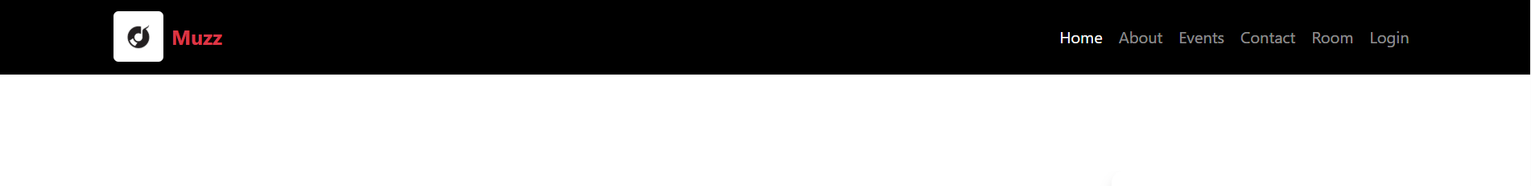

Step 6: Styling the Navigation Bar
In App.css (or TailwindCSS classes):
#root {
max-width: 1280px;
margin: 0 auto;
padding: 2rem;
text-align: center;
}

.logo {
height: 6em;
padding: 1.5em;
will-change: filter;
transition: filter 300ms;
}
.logo:hover {
filter: drop-shadow(0 0 2em #646cffaa);
}
.logo.react:hover {
filter: drop-shadow(0 0 2em #61dafbaa);
}

@keyframes logo-spin {
from {
transform: rotate(0deg);
}
to {
transform: rotate(360deg);
}
}

@media (prefers-reduced-motion: no-preference) {
a:nth-of-type(2) .logo {
animation: logo-spin infinite 20s linear;
}
}

.card {
padding: 2em;
}

.read-the-docs {
color: #888;
}

OUTPUT :

Code:
Home page:
import React from "react";
import { Link } from "react-router-dom";
import "./landing.css";
import Login from "../components/Login";

const Landing = () => {
return (
<div className="landing-container">
<section className="hero-section">
<div className="text-content">
<h1>Music for everyone.</h1>
<div className="cta-buttons">

<Link to="/login" className="primary-btn">
Try it free
</Link>

<a href="#" className="secondary-link">
Learn more
</a>
</div>
</div>

<div className="image-grid">
<img
src="https://stories.freepiklabs.com/api/vectors/music/rafiki/render?color=&background=complete&hide="
alt="Artist 1"
className="img-left"
/>
<div className="featured-card">
<img src="https://stories.freepiklabs.com/api/vectors/recording/amico/render?color=&background=complete"
alt="Artist 2"
className="img-main"
/>
<div className="card-overlay">
<h3>Today's Country</h3>
<p>Apple Music Country</p>
<small>
Discover all the ways you can showcase content on Music.
</small>
</div>
</div>
</div>
</section>
<footer className="scroll-nav"></footer>
</div>
);
};
export default Landing;

Output:
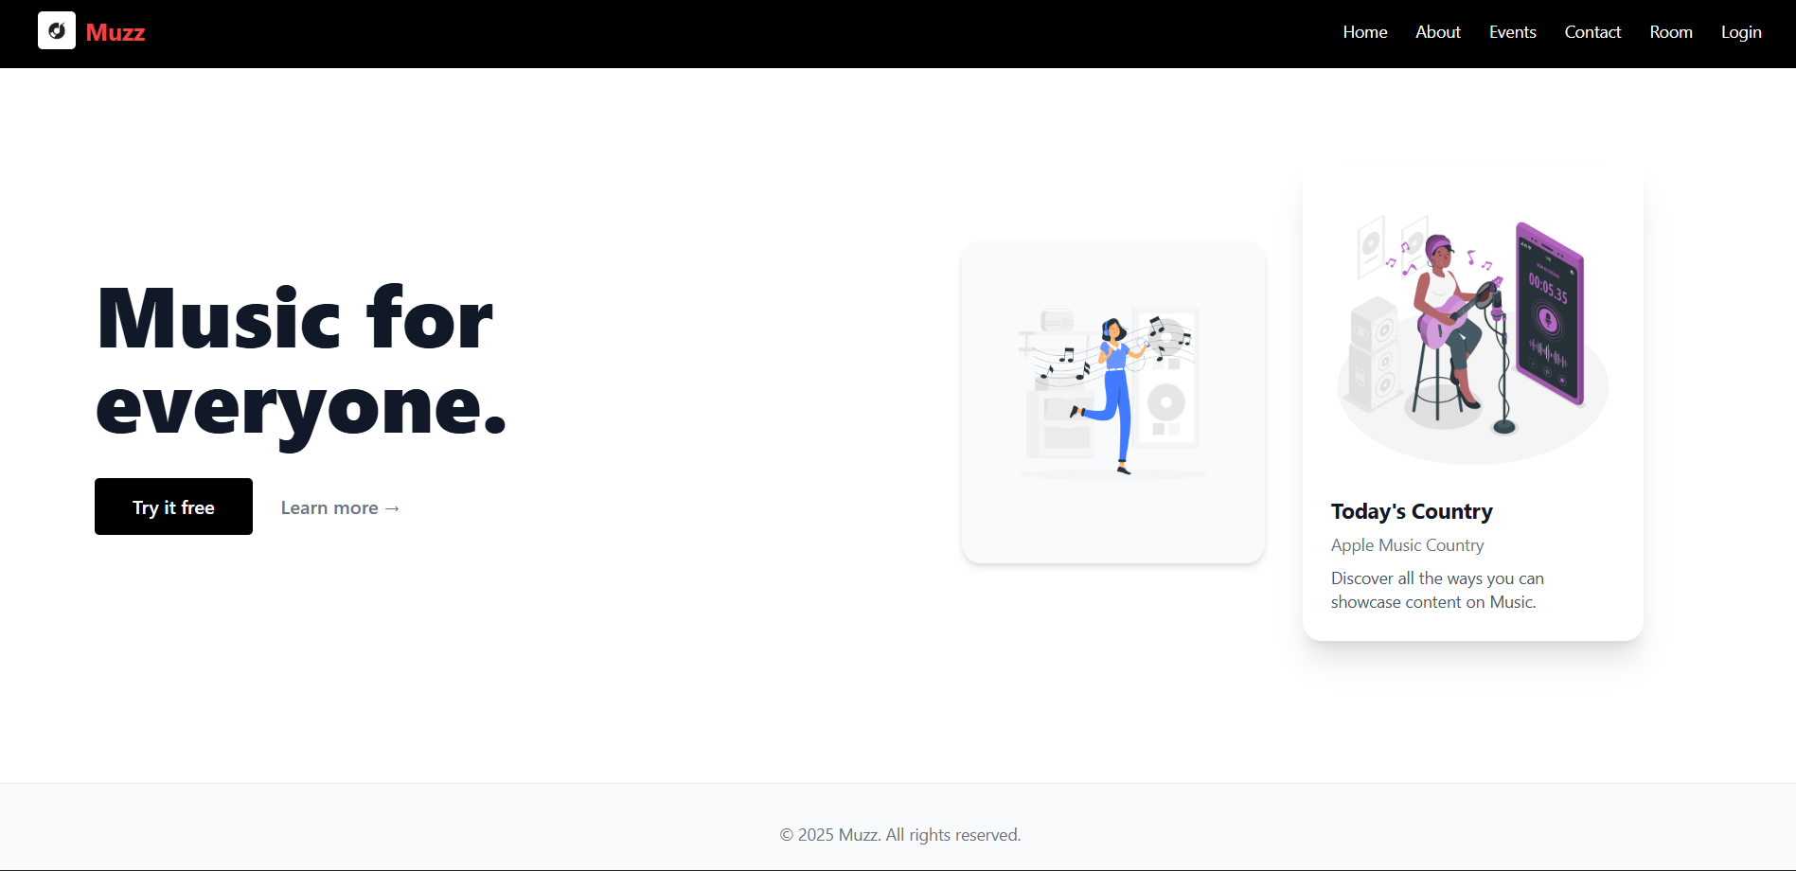

Code:
B. menu/room page:
import { useParams } from "react-router-dom";
import { useState } from "react";
import "./Room.css";

export default function Room() {
const { id } = useParams();
const [searchQuery, setSearchQuery] = useState("");
const [isPlaying, setIsPlaying] = useState(false);
const tracks = [
{ title: "Song 1 (Playing)", artist: "Artist Name", duration: "3:45" },
{ title: "Song 2", artist: "Another Artist", duration: "2:50" },
{ title: "Morning Breeze", artist: "Lo-Fi Beats", duration: "3:10" },
{ title: "Ocean Eyes", artist: "Billie Wave", duration: "4:00" },
];
const filteredTracks = tracks.filter(
(track) =>
track.title.toLowerCase().includes(searchQuery.toLowerCase()) ||
track.artist.toLowerCase().includes(searchQuery.toLowerCase())
);

const togglePlayPause = () => {
setIsPlaying((prev) => !prev);
};

return (
<div className="room-page-container">
<div className="main-app”
<div className="top-navbar">
<input
type="text"
placeholder="Search tracks..."
className="search-input"
value={searchQuery}
onChange={(e) => setSearchQuery(e.target.value)}
/>
<div>
<img
src="https://stories.freepiklabs.com/api/vectors/edit-photo/cuate/render?color=&background=complete"
alt="Profile"
className="user-profile"
/>
</div>
</div>
<div className="player-content-area">
<h2 className="room-header">Room: {id}</h2>

<div className="music-card-grid">
<div className="music-card card-purple">
<p className="card-title">28 Tracks</p>
<h4 className="card-subtitle">Release Radar</h4>
<img
src="https://stories.freepiklabs.com/api/vectors/edit-photo/cuate/render?color=&background=complete"
alt="User"
className="card-image-overlay"
/>
</div>
<div className="music-card card-cyan">
<p className="card-title">12 Tracks</p>
<h4 className="card-subtitle">Daily Mix</h4>
<img
src="https://stories.freepiklabs.com/api/vectors/profile-pic/bro/render?color=&background=complete&hide="
alt="User"
className="card-image-overlay"
/>
</div>
</div>

<div className="genres-and-tracks">
<div className="genre-panel">
<h4 className="panel-title">Genres</h4>
<div className="genre-button-grid">
<button className="genre-btn active">Classic</button>
<button className="genre-btn">House</button>
<button className="genre-btn">Minimal</button>
<button className="genre-btn">Hip-Hop</button>
<button className="genre-btn">Chillout</button>
<button className="genre-btn">Country</button>
<button className="genre-btn">Techno</button>
</div>
</div>

<div className="tracks-panel">
<h4 className="panel-title">Playlist / Queue</h4>
<ul className="list-group">
{filteredTracks.length > 0 ? (
filteredTracks.map((track, index) => (
<li className="track-list-item" key={index}>
<img
src="https://stories.freepiklabs.com/api/vectors/profile-pic/bro/render?color=&background=complete&hide="
alt="Art"
className="track-album-art"
/>
<div className="track-info">
<div className="track-details">{track.title}</div>
<div className="track-artist">{track.artist}</div>
</div>
<span className="track-duration">{track.duration}</span>
</li>
))
) : (
<p style={{ fontSize: "0.9rem", color: "#777" }}>
No tracks found.
</p>
)}
</ul>
</div>
</div>
</div>

<div className="friends-panel">
<h4 className="panel-title">Friends Activity</h4>
<div className="friend-item">
<img
src="https://stories.freepiklabs.com/api/vectors/profile-pic/rafiki/render?color=&background=complete&hide="
alt="Friend"
className="friend-avatar"
/>
<div className="friend-details">
<strong>Amber Holmes</strong>
<small>Dutch Kiss - Inner Mix</small>
</div>
</div>
<button className="view-all-btn">View All</button>
</div>
</div>

<div className="shared-player-bar">
<div className="player-controls">
<button>&#9664;</button>
<button onClick={togglePlayPause}>
{isPlaying ? "⏸️" : "▶️"}
</button>
<button>&#9658;</button>
</div>
<div className="player-progress-bar">
<span>1:20</span>
<div className="progress-line">
<div className="progress-filled"></div>
</div>
<span>4:30</span>
</div>
</div>
</div>
);

Output:
B. menu/room page output:
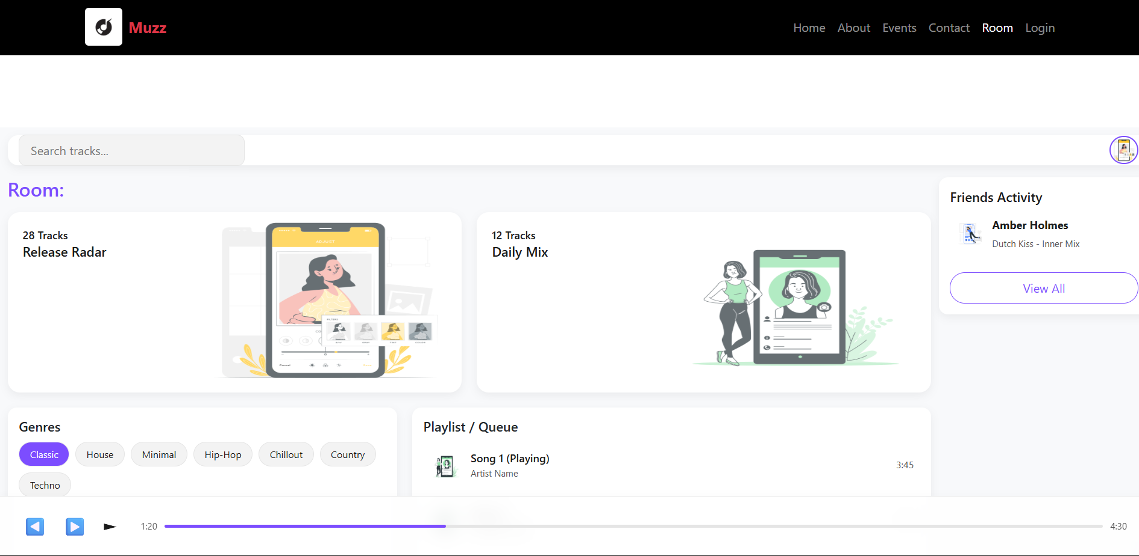

Code:
Event page:
export default function Events() {
const eventList = [
{ title: "DJ Night Party", date: "Nov 19", img: "/event1.jpg" },
{ title: "The Mission", date: "Nov 19", img: "/event2.jpg" },
{ title: "Planet Ibiza", date: "Nov 19", img: "/event3.jpg" },
];

return (
<section className="py-5 bg-dark text-white text-center">
<div className="container">
<h2 className="fw-light mb-5 text-uppercase" style={{ letterSpacing: "2px" }}>
Upcoming Events
</h2>
<div className="row g-4 justify-content-center">
{eventList.map((event, i) => (
<div className="col-md-4 col-sm-10" key={i}>
<div className="card border-0 position-relative overflow-hidden shadow-sm bg-transparent">
<div className="image-container position-relative">
<img
src="https://stories.freepiklabs.com/api/vectors/music-festival/bro/render?color=&background=complete"
className="card-img-top event-img"
alt={event.title}
/>
<div className="image-overlay d-flex flex-column justify-content-end text-start p-3">
<span className="badge bg-danger px-3 py-2 fs-6 align-self-start">
{event.date}
</span>
<h5 className="fw-semibold mt-3 mb-1 text-white">
{event.title}
</h5>
<p className="small text-light mb-0">
Don’t miss the night vibes
</p>
</div>
</div>
</div>
</div>
))}
</div>
</div>
</section>
);
}

Output:
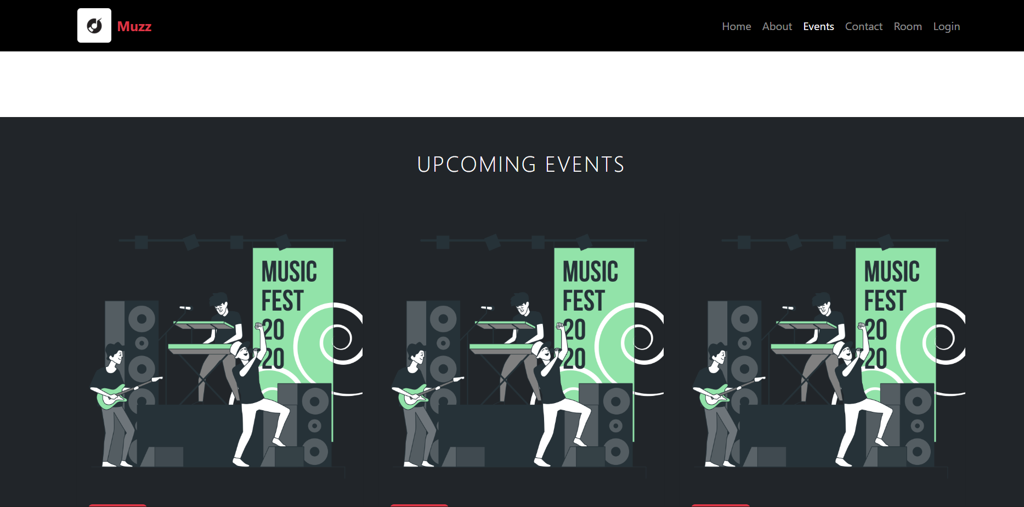

Code:
About us page:
export default function About() {
return (
<div className="card shadow-sm p-4 mx-auto" style={{ maxWidth: "700px" }}>
<h2 className="text-primary mb-3">About</h2>
<p>I’m a passionate web developer here to hear some music .</p>
</div>
);
}

OUTPUT :
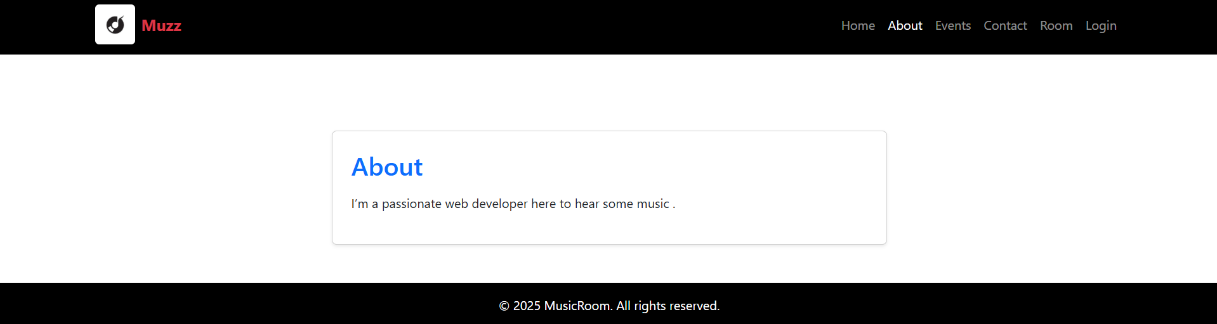

Code :
Login page
import React, { useState } from "react";
import { Link } from "react-router-dom";
import "./auth.css"; // shared styles for login + signup

const Login = () => {
const [formData, setFormData] = useState({ email: "", password: "" });

const handleChange = (e) => {
setFormData({ ...formData, [e.target.name]: e.target.value });
};

const handleSubmit = (e) => {
e.preventDefault();
console.log("Login data:", formData);

};

return (
<div className="auth-container">
<div className="auth-box">
<h2>Welcome Back 🎶</h2>
<p className="auth-subtitle">Log in to continue your music journey</p>

<form onSubmit={handleSubmit}>
<div className="input-group">
<label>Email</label>
<input
type="email"
name="email"
placeholder="you@example.com"
value={formData.email}
onChange={handleChange}
required
/>
</div>

<div className="input-group">
<label>Password</label>
<input
type="password"
name="password"
placeholder="••••••••"
value={formData.password}
onChange={handleChange}
required
/>
</div>
<button type="submit" className="primary-btn full-width">
Log In
</button>
</form>
<p className="auth-footer">
Don’t have an account?{" "}
<Link to="/register" className="auth-link">
Sign up
</Link>
</p>
</div>
</div>
);
};

export default Login;

OUTPUT :
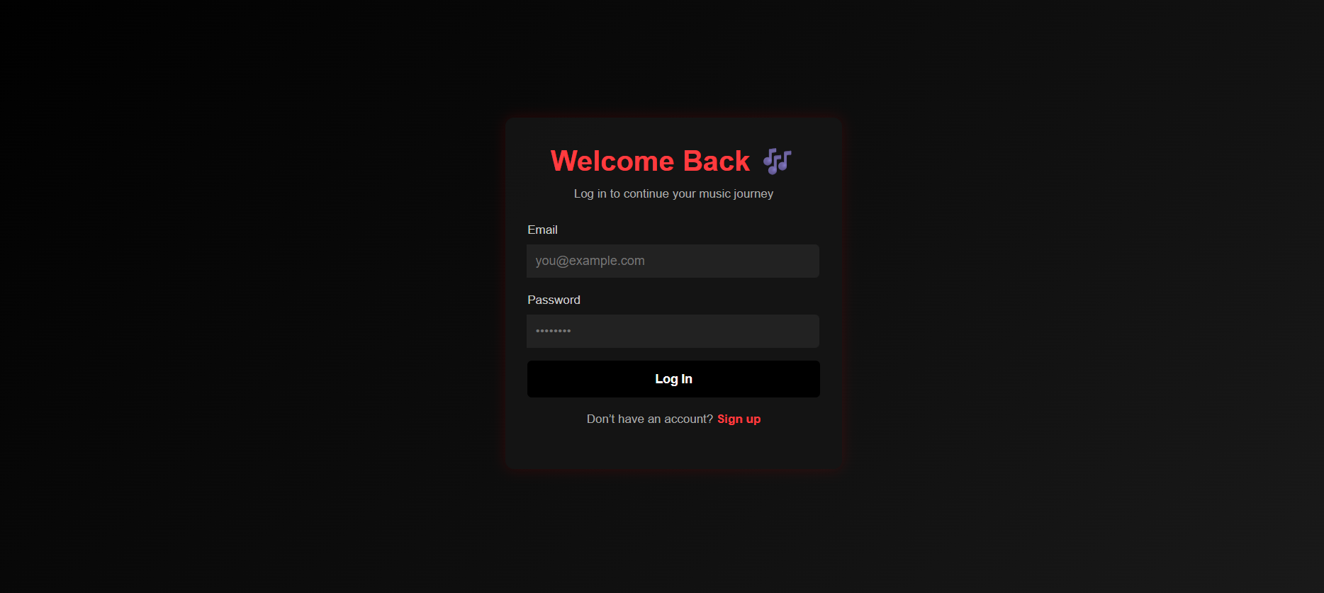
Code:
Register page
import React, { useState } from "react";
import { Link } from "react-router-dom";
import "./auth.css";

const Signup = () => {
const [formData, setFormData] = useState({
name: "",
email: "",
password: "",
});

const handleChange = (e) => {
setFormData({ ...formData, [e.target.name]: e.target.value });
};

const handleSubmit = (e) => {
e.preventDefault();
console.log("Signup data:", formData)
};
return (
<div className="auth-container">
<div className="auth-box">
<h2>Create Account 🎧</h2>
<p className="auth-subtitle">
Join the community and explore your favorite tracks
</p>
<form onSubmit={handleSubmit}>
<div className="input-group">
<label>Full Name</label>
<input
type="text"
name="name"
placeholder="John Doe"
value={formData.name}
onChange={handleChange}
required
/>
</div>
<div className="input-group">
<label>Email</label>
<input
type="email"
name="email"
placeholder="you@example.com"
value={formData.email}
onChange={handleChange}
required
/>
</div>
<div className="input-group">
<label>Password</label>
<input
type="password"
name="password"
placeholder="••••••••"
value={formData.password}
onChange={handleChange}
required
/>
</div>

<button type="submit" className="primary-btn full-width">
Sign Up
</button>
</form>
<p className="auth-footer">
Already have an account?{" "}
<Link to="/login" className="auth-link">
Log in
</Link>
</p>
</div>
</div>
);
};
export default Signup;

OUTPUT :
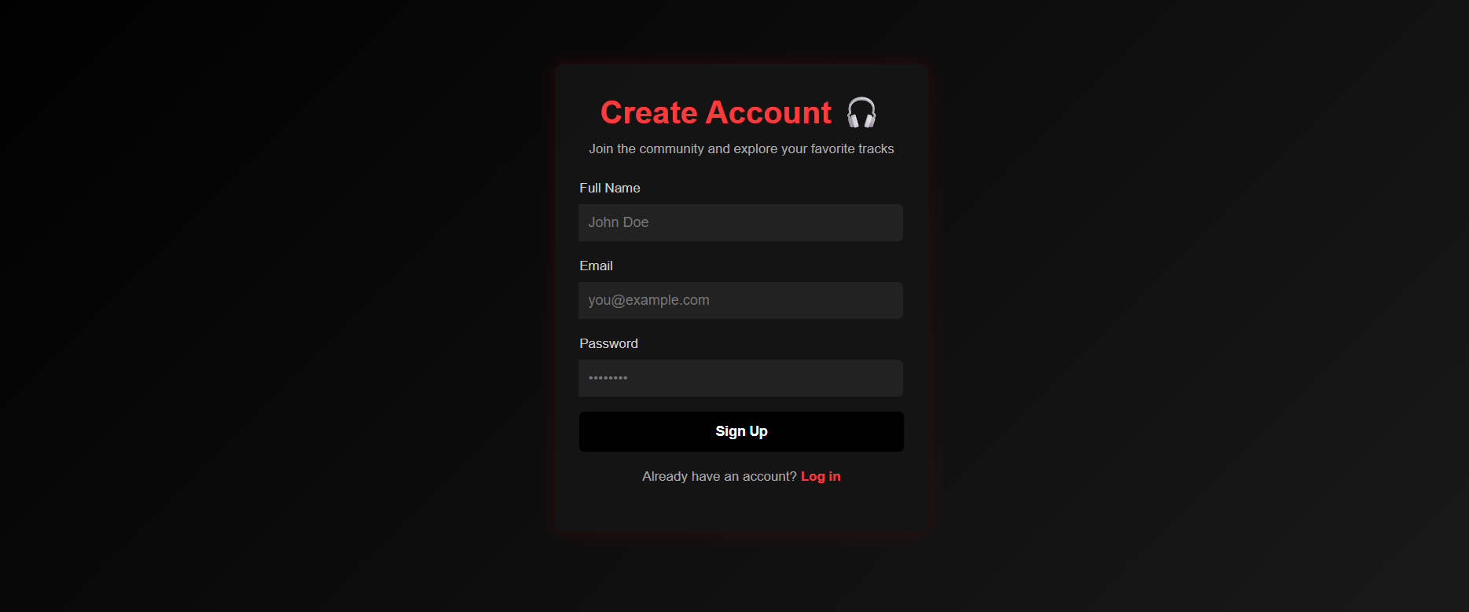

Conclusion
In this experiment, we successfully set up a ReactJS environment and implemented a basic navigation system for a web-based music listening platform. By using React Router DOM, we enabled seamless transitions between multiple pages — such as Home, Explore, Create Room, Join Room, and Profile — without reloading the browser, demonstrating the concept of a Single Page Application (SPA).
We learned how to structure a React project effectively, organize components and pages, and integrate a responsive navigation bar using Bootstrap/Tailwind for styling. This hands-on setup laid the foundation for developing a dynamic, scalable, and interactive music-sharing website where users can create or join listening rooms in real-time.

Experiment 2: Home Page Implementation

Objective
The goal of this phase is to design and develop the Home Page for the music website.
The Home Page is the first impression for users — it should introduce the app, highlight key features (like creating listening rooms), and allow users to search for music easily.
It also sets the design consistency for the entire project.

Concept Overview
The Home Page serves as the main landing area of the website.
In this music platform, users will:
- Explore songs or playlists,
- View trending rooms or popular genres,
- Use the search bar to find specific tracks, artists, or friends,
- Quickly navigate to other sections (like Profile, Rooms, or Create Room).
We’ll design this using React components to ensure reusability and scalability.

1. Designing the Home Page Layout

Concept:
The Home Page layout must be clean, user-friendly, and visually appealing.
We’ll use a component-based design where each section (banner, featured songs, search bar, etc.) is a separate React component.

Implementation Steps:
- Create a HomePage.jsx file in the src/pages directory.
- Add components such as:
  - Banner (hero section introducing the platform),
  - FeaturedSongs (displays trending or recommended tracks),
  - SearchBar (filters songs by name or category),
  - RoomHighlights (shows active rooms or popular genres).
- Ensure a responsive design that adjusts smoothly on mobile and desktop screens.
2. Adding Featured Products or Categories

Concept:
Although this is a music website (not an e-commerce site), we can replace “products” with featured playlists, albums, or artists.
This section showcases trending songs, newly added playlists, or top-rated community rooms.

Implementation Steps:
- Create a FeaturedSection component that dynamically loads a list of featured items.
Use mock JSON data initially:
const featuredSongs = [
{ id: 1, title: "Summer Vibes", artist: "DJ Nova", category: "Chill" },
{ id: 2, title: "Lo-Fi Lounge", artist: "BeatFlow", category: "Study" },
{ id: 3, title: "Party Beats", artist: "Max Tune", category: "Dance" }
];

Map over this array using:
{featuredSongs.map(song => (
<SongCard key={song.id} song={song} />
))}

- Each song card will include the song title, artist name, and a “Play Together” button.

3. Adding a Functional Search Bar

Concept:
The search bar allows users to quickly find songs, artists, or categories — improving navigation and user experience.
We’ll use state management (useState) in React to dynamically filter results based on user input.

Implementation Steps:
- Create a SearchBar.jsx component.
Add an <input> field that updates a state variable:
const [searchTerm, setSearchTerm] = useState("");

Filter the displayed songs based on input:
const filteredSongs = featuredSongs.filter(song =>
song.title.toLowerCase().includes(searchTerm.toLowerCase()) ||
song.category.toLowerCase().includes(searchTerm.toLowerCase())
);
- Update the UI dynamically to show only matching songs.
Code:
import Landing from '../pages/landing'
import "./home.css";

const Home = () => {
return (
<div className="home-container">

<Landing />

<section className="about-section py-5 text-center">
<div className="container">
<h2 className="section-title">About Our Music Platform</h2>
<p className="section-text mt-3">
Discover music like never before. Our platform connects artists,
listeners, and creators in one harmonious space. Whether you want
to explore new genres or share your passion with others, we’ve got
you covered.
</p>
</div>
</section>

<section className="events-section py-5">
<div className="container">
<h2 className="section-title text-center mb-4">Upcoming Events</h2>
<div className="row justify-content-center">
<div className="col-md-4">
<div className="event-card">
<img
src="https://images.unsplash.com/photo-1511379938547-c1f69419868d"
alt="Live Concert"
/>
<h4>Live Concert Nights</h4>
<p>Experience the best live music events happening near you.</p>
</div>
</div>
<div className="col-md-4">
<div className="event-card">
<img
src="https://images.unsplash.com/photo-1511671782779-c97d3d27a1d4"
alt="DJ Party"
/>
<h4>DJ Party Weekend</h4>
<p>Join the hottest DJs spinning your favorite tracks.</p>
</div>
</div>
<div className="col-md-4">
<div className="event-card">
<img
src="https://images.unsplash.com/photo-1507874457470-272b3c8d8ee2"
alt="Acoustic Session"
/>
<h4>Acoustic Sessions</h4>
<p>Chill vibes with acoustic performances from top artists.</p>
</div>
</div>
</div>
</div>
</section>

<section className="cta-section py-5 text-center">
<div className="container">
<h2>Start Your Music Journey Today</h2>
<p>Join thousands of users discovering new music every day.</p>
<button className="primary-btn">Get Started</button>
</div>
</section>

<footer className="footer py-4 text-center">
<p>© {new Date().getFullYear()} MyMusic. All rights reserved.</p>
</footer>
</div>
);
};

export default Home;

OUTPUT :

Conclusion

By the end of this stage, the Home Page will be fully developed with a clean and functional user interface. It will dynamically display featured songs and playlists while allowing users to search and filter music effortlessly. In addition, seamless navigation across pages — such as the Home, Profile, and Create Room sections — will be achieved through React Router DOM, ensuring a smooth and engaging user experience.

Experiment 3: Product Listing Page Implementation

Objective
The objective of this stage is to fetch music data (like songs, artists, or playlists) from a static array or a JSON file and display it dynamically on the website.
Each song will have its image, name, artist, and a “Play” or “Add to Cart” button (depending on the feature).
We’ll also set up navigation to individual music detail pages using React Router.

1. Fetching Product (Music) Data

Concept:
Since backend integration isn’t added yet, we’ll store our music data (songs, playlists, or albums) locally in:
- A JavaScript array, or
- A static JSON file (like songs.json).
This will simulate how real APIs work when fetching music data from a server.

Implementation Steps:
- Create a folder named data inside the src directory.
- Inside it, create a file named songs.json or songsData.js.
Example data:
[
{
"id": 1,
"title": "Ocean Drive",
"artist": "Duke Dumont",
"image": "https://example.com/ocean.jpg",
"price": "Free"
},
{
"id": 2,
"title": "Midnight City",
"artist": "M83",
"image": "https://example.com/midnight.jpg",
"price": "Premium"
},
{
"id": 3,
"title": "Sunset Lover",
"artist": "Petit Biscuit",
"image": "https://example.com/sunset.jpg",
"price": "Free"
}
]

Import this file in your HomePage.jsx or FeaturedSection.jsx:
import songsData from "../data/songs.json";

Use the useEffect() hook to load it:
const [songs, setSongs] = useState([]);

useEffect(() => {
setSongs(songsData);
}, []);

2. Displaying Song (Product) Information

Concept:
Each song will be displayed in a card format showing:
- Album cover (image)
- Song name
- Artist name
- Price or tag (e.g., “Free” or “Premium”)
- An Add to Cart / Play Together button
We’ll create a Room.jsx component for this purpose.

3. Add to Cart / Playlist Functionality

Concept:
This step simulates adding a song to a “playlist” or “queue.”
In a real-world version, it would store the song in a user’s playlist or shared room.

Implementation Steps:
Create a state variable in a parent component to store added songs:
const [playlist, setPlaylist] = useState([]);

Pass an onAdd function to SongCard:
const handleAddToPlaylist = (song) => {
setPlaylist([...playlist, song]);
};
- Modify the button:
<button onClick={() => onAdd(song)}>Add to Playlist</button>

- You can later display the playlist items in a sidebar or another page.

4. React Router Links for Navigation
Each song card will have a link to its detail page, where users can view more information about that specific track (like album info, lyrics, or “Listen with friends” option).

Code :
import { useParams } from "react-router-dom";
import { useState } from "react";
import "./Room.css";

export default function Room() {
const { id } = useParams();

const [searchQuery, setSearchQuery] = useState("");
const [isPlaying, setIsPlaying] = useState(false);

const tracks = [
{ title: "Song 1 (Playing)", artist: "Artist Name", duration: "3:45" },
{ title: "Song 2", artist: "Another Artist", duration: "2:50" },
{ title: "Morning Breeze", artist: "Lo-Fi Beats", duration: "3:10" },
{ title: "Ocean Eyes", artist: "Billie Wave", duration: "4:00" },
];

const filteredTracks = tracks.filter(
(track) =>
track.title.toLowerCase().includes(searchQuery.toLowerCase()) ||
track.artist.toLowerCase().includes(searchQuery.toLowerCase())
);

const togglePlayPause = () => {
setIsPlaying((prev) => !prev);
};

return (
<div className="room-page-container">
<div className="main-app-container">

<div className="top-navbar">
<input
type="text"
placeholder="Search tracks..."
className="search-input"
value={searchQuery}
onChange={(e) => setSearchQuery(e.target.value)}
/>
<div>
<img
src="https://stories.freepiklabs.com/api/vectors/edit-photo/cuate/render?color=&background=complete"
alt="Profile"
className="user-profile"
/>
</div>
</div>

<div className="player-content-area">
<h2 className="room-header">Room: {id}</h2>

<div className="music-card-grid">
<div className="music-card card-purple">
<p className="card-title">28 Tracks</p>
<h4 className="card-subtitle">Release Radar</h4>
<img
src="https://stories.freepiklabs.com/api/vectors/edit-photo/cuate/render?color=&background=complete"
alt="User"
className="card-image-overlay"
/>
</div>
<div className="music-card card-cyan">
<p className="card-title">12 Tracks</p>
<h4 className="card-subtitle">Daily Mix</h4>
<img
src="https://stories.freepiklabs.com/api/vectors/profile-pic/bro/render?color=&background=complete&hide="
alt="User"
className="card-image-overlay"
/>
</div>
</div>

<div className="genres-and-tracks">
<div className="genre-panel">
<h4 className="panel-title">Genres</h4>
<div className="genre-button-grid">
<button className="genre-btn active">Classic</button>
<button className="genre-btn">House</button>
<button className="genre-btn">Minimal</button>
<button className="genre-btn">Hip-Hop</button>
<button className="genre-btn">Chillout</button>
<button className="genre-btn">Country</button>
<button className="genre-btn">Techno</button>
</div>
</div>

<div className="tracks-panel">
<h4 className="panel-title">Playlist / Queue</h4>
<ul className="list-group">
{filteredTracks.length > 0 ? (
filteredTracks.map((track, index) => (
<li className="track-list-item" key={index}>
<img
src="https://stories.freepiklabs.com/api/vectors/profile-pic/bro/render?color=&background=complete&hide="
alt="Art"
className="track-album-art"
/>
<div className="track-info">
<div className="track-details">{track.title}</div>
<div className="track-artist">{track.artist}</div>
</div>
<span className="track-duration">{track.duration}</span>
</li>
))
) : (
<p style={{ fontSize: "0.9rem", color: "#777" }}>
No tracks found.
</p>
)}
</ul>
</div>
</div>
</div>

<div className="friends-panel">
<h4 className="panel-title">Friends Activity</h4>
<div className="friend-item">
<img
src="https://stories.freepiklabs.com/api/vectors/profile-pic/rafiki/render?color=&background=complete&hide="
alt="Friend"
className="friend-avatar"
/>
<div className="friend-details">
<strong>Amber Holmes</strong>
<small>Dutch Kiss - Inner Mix</small>
</div>
</div>
<button className="view-all-btn">View All</button>
</div>
</div>

<div className="shared-player-bar">
<div className="player-controls">
<button>&#9664;</button>
<button onClick={togglePlayPause}>
{isPlaying ? "⏸️" : "▶️"}
</button>
<button>&#9658;</button>
</div>
<div className="player-progress-bar">
<span>1:20</span>
<div className="progress-line">
<div className="progress-filled"></div>
</div>
<span>4:30</span>
</div>
</div>
</div>
);
}

OUTPUT :

Conclusion
By the end of this stage, music data—including songs and playlists—will be dynamically loaded from a JSON file or array. Each song card will showcase its image, title, artist, and price or tag. The Add to Playlist button will update the local state accordingly, and every card will provide a link to a detailed page using React Router for smooth navigation.

Experiment 4: Product Details Page Implementation

Objective
The goal of this stage is to create a dedicated page for each song or music item.
When a user clicks on a song from the homepage or featured list, they should be navigated to this detail page using React Router.
This page enhances user engagement by showing full information about the selected song and providing interactive options like playing it, adding to playlist, or sharing it with friends.

Conceptual Understanding
In a typical e-commerce website, the Product Details Page gives users complete information before purchasing an item.
Similarly, in your Music Website, this page gives users a complete view of a selected song or album — including visuals, metadata, and play options.

Real-World Example:
On Spotify or YouTube Music, when you click on a song or album:
- You see its cover art.
- The artist and album details appear.
- You can play, like, share, or add it to a playlist.

Step-by-Step Implementation

Routing Setup
import React from "react";
import { BrowserRouter as Router, Routes, Route } from "react-router-dom";

import Landing from "./pages/landing"
import Home from "./components/Home";
import About from "./components/About";
import Contact from "./components/Contact";
import Login from "./components/Login";
import Register from "./components/Register";
import Room from "./components/Room";
import Events from "./components/Events";
import Header from "./components/Header";
import Footer from "./components/Footer";

const App = () => {
return (
<Router>
<Header />
<Routes>

<Route path="/" element={<Landing />} />

<Route path="/home" element={<Home />} />

<Route path="/about" element={<About />} />
<Route path="/events" element={<Events />} />
<Route path="/room" element={<Room />} />
<Route path="/contact" element={<Contact />} />

<Route path="/login" element={<Login />} />
<Route path="/register" element={<Register />} />

<Route
path="*"
element={
<div style={{ textAlign: "center", padding: "100px", color: "#fff", background: "#000" }}>
<h2>404 - Page Not Found</h2>
<p>The page you’re looking for doesn’t exist.</p>
</div>
}
/>
</Routes>
<Footer />
</Router>
);
};
export default App;

Linking from the Homepage
On your HomePage.jsx (or wherever songs are displayed), use Link from react-router-dom to route to the Song Detail Page when a user clicks on a song.
import { useParams } from "react-router-dom";
import { useState } from "react";
import "./Room.css";

export default function Room() {
const { id } = useParams();

const [searchQuery, setSearchQuery] = useState("");
const [isPlaying, setIsPlaying] = useState(false);

const tracks = [
{ title: "Song 1 (Playing)", artist: "Artist Name", duration: "3:45" },
{ title: "Song 2", artist: "Another Artist", duration: "2:50" },
{ title: "Morning Breeze", artist: "Lo-Fi Beats", duration: "3:10" },
{ title: "Ocean Eyes", artist: "Billie Wave", duration: "4:00" },
];

const filteredTracks = tracks.filter(
(track) =>
track.title.toLowerCase().includes(searchQuery.toLowerCase()) ||
track.artist.toLowerCase().includes(searchQuery.toLowerCase())
);

const togglePlayPause = () => {
setIsPlaying((prev) => !prev);
};

return (
<div className="room-page-container">
<div className="main-app-container">

<div className="top-navbar">
<input
type="text"
placeholder="Search tracks..."
className="search-input"
value={searchQuery}
onChange={(e) => setSearchQuery(e.target.value)}
/>
<div>
<img
src="https://stories.freepiklabs.com/api/vectors/edit-photo/cuate/render?color=&background=complete"
alt="Profile"
className="user-profile"
/>
</div>
</div>

<div className="player-content-area">
<h2 className="room-header">Room: {id}</h2>

<div className="music-card-grid">
<div className="music-card card-purple">
<p className="card-title">28 Tracks</p>
<h4 className="card-subtitle">Release Radar</h4>
<img
src="https://stories.freepiklabs.com/api/vectors/edit-photo/cuate/render?color=&background=complete"
alt="User"
className="card-image-overlay"
/>
</div>
<div className="music-card card-cyan">
<p className="card-title">12 Tracks</p>
<h4 className="card-subtitle">Daily Mix</h4>
<img
src="https://stories.freepiklabs.com/api/vectors/profile-pic/bro/render?color=&background=complete&hide="
alt="User"
className="card-image-overlay"
/>
</div>
</div>

<div className="genres-and-tracks">
<div className="genre-panel">
<h4 className="panel-title">Genres</h4>
<div className="genre-button-grid">
<button className="genre-btn active">Classic</button>
<button className="genre-btn">House</button>
<button className="genre-btn">Minimal</button>
<button className="genre-btn">Hip-Hop</button>
<button className="genre-btn">Chillout</button>
<button className="genre-btn">Country</button>
<button className="genre-btn">Techno</button>
</div>
</div>

<div className="tracks-panel">
<h4 className="panel-title">Playlist / Queue</h4>
<ul className="list-group">
{filteredTracks.length > 0 ? (
filteredTracks.map((track, index) => (
<li className="track-list-item" key={index}>
<img
src="https://stories.freepiklabs.com/api/vectors/profile-pic/bro/render?color=&background=complete&hide="
alt="Art"
className="track-album-art"
/>
<div className="track-info">
<div className="track-details">{track.title}</div>
<div className="track-artist">{track.artist}</div>
</div>
<span className="track-duration">{track.duration}</span>
</li>
))
) : (
<p style={{ fontSize: "0.9rem", color: "#777" }}>
No tracks found.
</p>
)}
</ul>
</div>
</div>
</div>

<div className="friends-panel">
<h4 className="panel-title">Friends Activity</h4>
<div className="friend-item">
<img
src="https://stories.freepiklabs.com/api/vectors/profile-pic/rafiki/render?color=&background=complete&hide="
alt="Friend"
className="friend-avatar"
/>
<div className="friend-details">
<strong>Amber Holmes</strong>
<small>Dutch Kiss - Inner Mix</small>
</div>
</div>
<button className="view-all-btn">View All</button>
</div>
</div>

<div className="shared-player-bar">
<div className="player-controls">
<button>&#9664;</button>
<button onClick={togglePlayPause}>
{isPlaying ? "⏸️" : "▶️"}
</button>
<button>&#9658;</button>
</div>
<div className="player-progress-bar">
<span>1:20</span>
<div className="progress-line">
<div className="progress-filled"></div>
</div>
<span>4:30</span>
</div>
</div>
</div>
);
}

OUTPUT:

Fetching the Correct Song Data
The page needs to display the specific song that was clicked.
To do this, we’ll use the useParams() hook to extract the id from the URL and find that song from our static JSON file or array.

Conclusion
In this stage, I successfully developed a dynamic Product Details Page using React Router, enabling users to view individual product information and select quantities before adding items to the cart. This experience strengthened my skills in dynamic routing with useParams(), fetching and displaying specific product data, handling interactive inputs, and enhancing the overall UI/UX for product exploration pages.

Experiment 5: Cart Page Implementation in ReactJS
The Cart Page is a crucial part of your React music website — even though it’s not a traditional e-commerce store, you can still use cart-like functionality for features such as adding songs, playlists, or subscription plans that users wish to purchase or share.
For example, users could “add to cart” a premium room plan, a specific song bundle, or shared playlist access.

Objective
The goal of this part is to build a Cart page that displays all the items (like music bundles, room access passes, or merchandise) added by the user, allows them to modify their selection, view the total cost, and proceed to checkout.

Conceptual Understanding

1. Cart Page Design
The Cart page will serve as a centralized place where the user can:
- Review the items they’ve added.
- Modify quantities (like the number of users for a group listening plan).
- Remove items they no longer wish to include.
- View the total price in real-time.
- Proceed to checkout or continue browsing.
The layout typically includes:
- Product image or thumbnail (album art or item picture)
- Product name (song, plan, or product title)
- Price per item
- Quantity selector (increase/decrease buttons)
- Subtotal per item
- Total price at the bottom
- Navigation buttons: Continue Shopping and Proceed to Checkout

Core React Concepts Used

useState() Hook
Used to manage the state of:
- Items in the cart
- Quantity of each item
- Total cost
Example:
const [cartItems, setCartItems] = useState([]);

This allows dynamic re-rendering whenever a user updates quantity or removes an item.

useEffect() Hook
This hook can be used to recalculate the total cost whenever the cart items change:
useEffect(() => {
calculateTotal();
}, [cartItems]);

This ensures that any addition, deletion, or modification reflects instantly in the total amount.

Array Methods (map, filter, reduce)
React heavily depends on JavaScript array methods to render lists and manage state updates.
- map() — To display cart items dynamically.
- filter() — To remove items when “Remove” is clicked.
- reduce() — To calculate the total price.
Example:
const total = cartItems.reduce((acc, item) => acc + item.price * item.quantity, 0);

3. Cart Operations

Add Item to Cart
When a user clicks “Add to Cart” on the product page, the item is stored in a state variable or context.
You can use React Context API or Redux for global cart management.
Example:
function addToCart(product) {
setCartItems([...cartItems, product]);
}

Remove Item from Cart
Users should be able to delete an item from the cart:
function removeFromCart(id) {
setCartItems(cartItems.filter(item => item.id !== id));
}

Change Quantity
Provide buttons or a number input field to increase/decrease the quantity:
function updateQuantity(id, newQty) {
setCartItems(cartItems.map(item =>
item.id === id ? { ...item, quantity: newQty } : item
));
}

4. Styling and UI Components
To enhance user experience, you can use:
- Tailwind CSS or Bootstrap for layout.
- React Icons for buttons (e.g., trash icon for delete).
- Responsive design to ensure usability on both desktop and mobile.
Example Layout:
Product Image | Product Name | Quantity | Price | Remove
🎵 | Premium Music Pass | 1 | ₹299
At the bottom:
Total: ₹299
[Continue Shopping] [Proceed to Checkout]

5. React Router Integration
Use React Router to navigate between:
- Home → Product Details → Cart → Checkout.
Example:
import { Link } from 'react-router-dom';

<Link to="/checkout" className="btn btn-primary">Proceed to Checkout</Link>
<Link to="/products" className="btn btn-secondary">Continue Shopping</Link>

6. State Management Tools
For scalability, use:
- React Context API — Simplifies passing state across components without prop drilling.
- Redux Toolkit — Recommended for larger apps with complex cart operations or user states.

7. Calculation of Total Cost
Total cost dynamically updates as user modifies the cart.
Example:
const totalPrice = cartItems.reduce(
(total, item) => total + item.price * item.quantity,
0
);

This ensures real-time cost updates without reloading.

8. Future Enhancements
In your music website, cart functionality can be extended to:
- Save user’s cart data in localStorage (so it persists after refresh).
- Sync with backend API to fetch/save cart items for logged-in users.
- Add discount codes or subscription offers.
- Integrate with a payment gateway (like Razorpay, Stripe, or PayPal).
Code:
import React from "react";

export default function Events() {
const eventList = [
{
title: "DJ Night Party",
date: "Nov 19",
img: "https://stories.freepiklabs.com/api/vectors/music-festival/bro/render?color=&background=complete",
},
{
title: "The Mission",
date: "Nov 19",
img: "https://stories.freepiklabs.com/api/vectors/dancing/rafiki/render?color=&background=complete",
},
{
title: "Planet Ibiza",
date: "Nov 19",
img: "https://stories.freepiklabs.com/api/vectors/recording/bro/render?color=&background=complete",
},
];

return (
<section className="py-20 bg-[#0d0d0d] text-white text-center min-h-screen">
<div className="max-w-7xl mx-auto px-6">
<h2 className="text-3xl md:text-4xl font-light uppercase tracking-[4px] mb-12 text-red-500">
Upcoming Events
</h2>

<div className="grid grid-cols-1 sm:grid-cols-2 lg:grid-cols-3 gap-10 justify-items-center">
{eventList.map((event, i) => (
<div
key={i}
className="relative rounded-2xl overflow-hidden bg-[#1e1e1e] shadow-md hover:shadow-xl transition-all duration-300 w-full max-w-sm"
>
<div className="relative group">
<img
src={event.img}
alt={event.title}
className="rounded-2xl w-full h-[280px] object-cover transform transition-transform duration-500 group-hover:scale-105 group-hover:opacity-90"
/>

<div className="absolute inset-0 bg-gradient-to-t from-black/70 to-transparent opacity-0 group-hover:opacity-100 transition-opacity duration-500 flex flex-col justify-end p-5">
<span className="bg-red-600 text-white px-4 py-1 rounded-md text-sm font-semibold self-start">
{event.date}
</span>
<h5 className="text-lg font-semibold mt-3 mb-1">
{event.title}
</h5>
<p className="text-sm text-gray-300">
Don’t miss the night vibes
</p>
</div>
</div>
</div>
))}
</div>
</div>
</section>
);
}

OUTPUT:
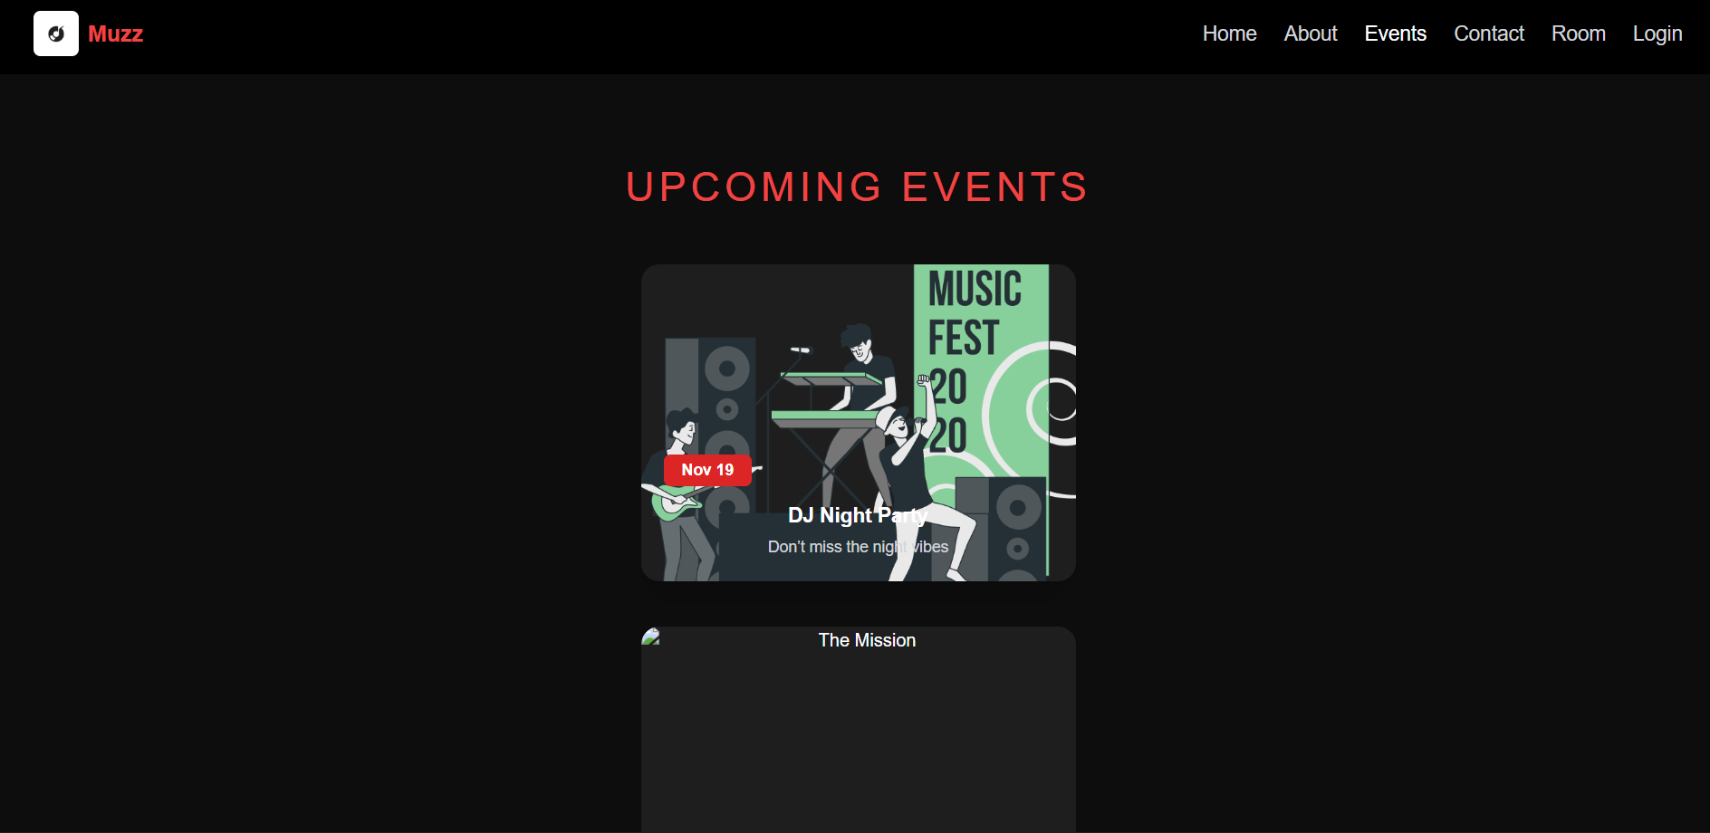
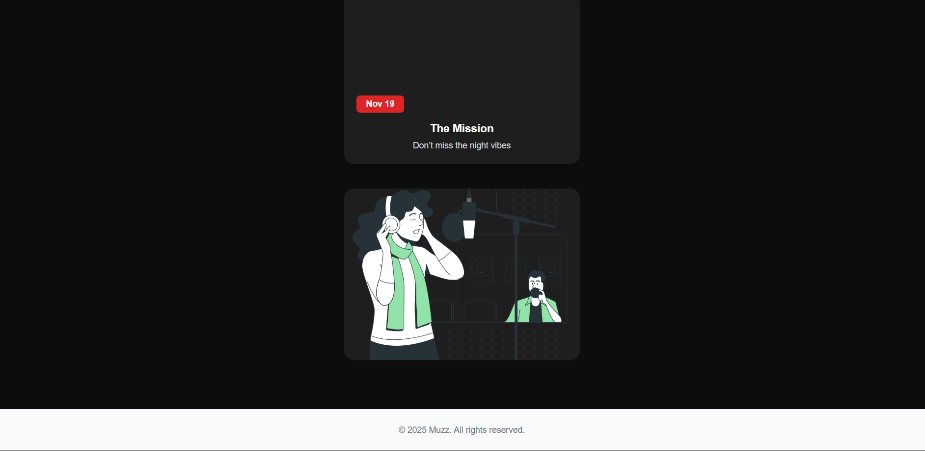

Conclusion
The Cart page ties together state management, routing, and UI rendering — fundamental aspects of a React project. In your music-sharing website, this can be adapted to let users manage music room subscriptions, premium plans, or shared playlists efficiently.
This component ensures users have control, clarity, and convenience while managing their interactions and purchases on the platform.

Experiment 6: Checkout Page Implementation in ReactJS
The User Profile Page is the heart of personalization in your music website.
It provides a dedicated space for users to view and manage their personal details, order or subscription history, and even preferences related to their listening experience (like playlists, favorite artists, or rooms created).
In an application where users listen to music together, the profile page enhances engagement by allowing each listener to maintain an individual identity within the shared experience.
Objective
The objective of the User Profile Page is to:
- Display user details such as name, email, profile picture, and subscription type.
- Show order history or subscription records (dummy or stored locally).
- Provide a form to update personal information dynamically.
- Offer a user-friendly, responsive interface that reflects personalization and ownership.

Core Components of the Profile Page

1. User Information Display Section
This section presents the user’s basic account information — such as:
- Name
- Email
- Subscription Type (e.g., Free / Premium / Room Host)
- Profile Picture
It gives users an overview of who they are within the platform and establishes a personalized experience.

2. Edit Profile Form
The Edit Profile Form allows users to modify their personal details such as:
- Name
- Email
- Password (optional for advanced features)
- Address (if used for billing or event notifications)
Users can easily update their data using controlled form components in React.

Once submitted, the updated information can be:
- Saved in React State (temporary)
- Persisted in localStorage (permanent)
- Or synced with a backend database (for real-time data persistence)

3. Order / Subscription History
For your music website, this section could display:
- Previous subscriptions (e.g., Monthly Premium, Concert Access Pass)
- Room creation history (list of rooms user hosted or joined)
- Past transactions (if applicable)
Example representation:
Date | Plan | Amount | Status
10 Oct 2025 | Premium Monthly | ₹499 | Active
02 Sep 2025 | Free Plan | ₹0 | Expired

React Concepts and Tools Used

1. React useState()
Used to manage user data and form inputs dynamically.
const [user, setUser] = useState({
name: "Sanskrti",
email: "sanskrti@musicwave.com",
subscription: "Premium"
});

2. React useEffect()
Used to fetch or load user profile data when the component first mounts.
useEffect(() => {
const storedUser = JSON.parse(localStorage.getItem("user"));
if (storedUser) setUser(storedUser);
}, []);

3. localStorage for Data Persistence
Since your project might not yet have a backend, you can use localStorage to save and retrieve profile data even after page reloads.
localStorage.setItem("user", JSON.stringify(user));

This ensures that user preferences (like display name or subscription type) stay consistent across sessions.

4. React Router DOM
Navigation links let users move from Profile → Home → Room → Playlist seamlessly.
<Link to="/home">Back to Home</Link>
<Link to="/rooms">My Rooms</Link>

5. Component Reusability
The profile page can use reusable components like:
- <ProfileCard />
- <SubscriptionTable />
- <EditProfileForm />
This modular structure improves code readability and maintainability.

Design & Layout
Use Bootstrap, Tailwind CSS, or CSS Grid/Flexbox to create a responsive and attractive profile interface.

Suggested Layout:
Section | Description
Header | User’s name & avatar
Left Column | Edit Profile Form
Right Column | Order / Subscription History
Bottom Section | Buttons for Logout, Upgrade Plan, or Join New Room

CSS Concepts:
- d-flex and justify-content-between for side-by-side layout
- rounded-circle for circular profile images
- text-muted for secondary information
- shadow-lg for elevation and focus

Form Validation and User Experience
Before updating details, simple validation ensures:
- Email format is correct
- No fields are empty
- Password confirmation matches
CODE :
.export default function Events() {
const eventList = [
{ title: "DJ Night Party", date: "Nov 19", img: "/event1.jpg" },
{ title: "The Mission", date: "Nov 19", img: "/event2.jpg" },
{ title: "Planet Ibiza", date: "Nov 19", img: "/event3.jpg" },
];

return (
<section className="py-5 bg-dark text-white text-center">
<div className="container">
<h2 className="fw-light mb-5 text-uppercase" style={{ letterSpacing: "2px" }}>
Upcoming Events
</h2>
<div className="row g-4 justify-content-center">
{eventList.map((event, i) => (
<div className="col-md-4 col-sm-10" key={i}>
<div className="card border-0 position-relative overflow-hidden shadow-sm bg-transparent">
<div className="image-container position-relative">
<img
src="https://stories.freepiklabs.com/api/vectors/music-festival/bro/render?color=&background=complete"
className="card-img-top event-img"
alt={event.title}
/>
<div className="image-overlay d-flex flex-column justify-content-end text-start p-3">
<span className="badge bg-danger px-3 py-2 fs-6 align-self-start">
{event.date}
</span>
<h5 className="fw-semibold mt-3 mb-1 text-white">
{event.title}
</h5>
<p className="small text-light mb-0">
Don’t miss the night vibes
</p>
</div>
</div>
</div>
</div>
))}
</div>
</div>
</section>
);
}

OUTPUT :
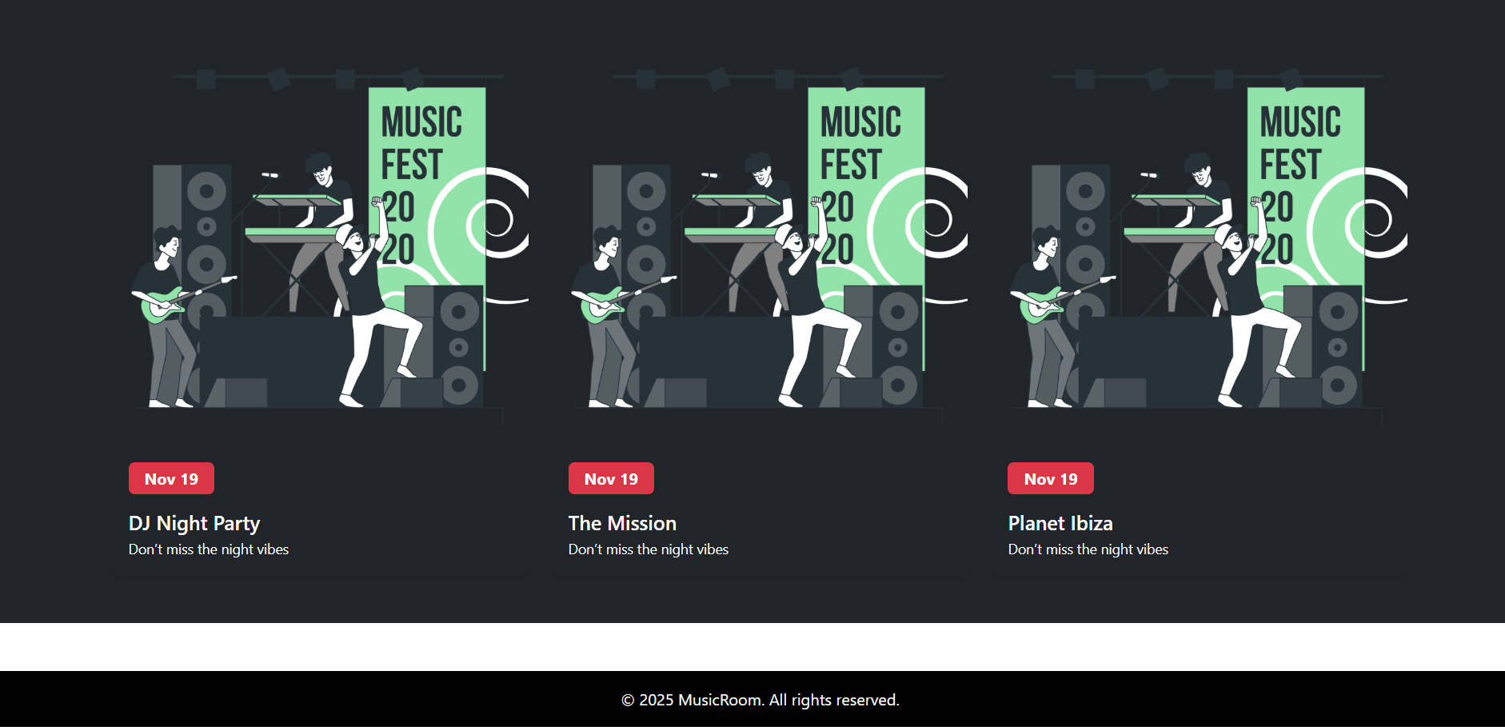
Conclusion
The User Profile Page forms a vital part of the user-centered design of your React Music Website.
It combines React state management, form handling, data persistence, and responsive design principles to give users complete control over their experience.
By implementing this module, you’ll gain hands-on understanding of:
- React forms and input handling
- Local storage usage for real-world apps
- Component-based architecture for scalable UI
- Maintaining user engagement through personalization

Experiment 7 : User Profile Page Implementation in ReactJS

Objective:
To develop a User Profile Page in the Muzz application where users can view and update their personal details, as well as access their order history in an organized and interactive layout.

Theory:
The User Profile Page serves as a central hub for users to manage their personal data and view past interactions or transactions within the application. It enhances user experience by offering personalization, data transparency, and control over account information.
In ReactJS, this page can be built using functional components, state hooks, and form handling techniques. The user’s data can be stored locally or fetched from an API. Updating profile details typically involves controlled forms, validation, and dynamic rendering.
For DrawKit, a collaborative whiteboarding tool, the User Profile Page can store user credentials, team collaboration settings, or purchased design assets. Integrating such a page helps manage personalized experiences, such as saving preferred templates or tracking subscription plans.
Key Concepts Involved:
● Controlled components for form handling
● State management using useState and useContext.
● React Router navigation and conditional rendering.
● API integration or mock JSON data for order history.

Tools and Technologies Used:
● Frontend: ReactJS
● Routing: React Router
● State Management: Context API / useState
● Styling: CSS / Tailwind CSS / Material UI
● Data Handling: JSON file / API for order history
● Form Validation: HTML5 validation or custom functions

Procedure / Tasks:
- Create Profile Component:
○ Create a new file Profile.jsx in the src/components directory.
○ Import necessary dependencies such as React, useState, and useContext.
- Display User Information:
○ Fetch or define static user details such as name, email, and shipping address.
○ Render these details in read-only mode initially.
- Profile Update Form:
○ Add editable input fields for Name, Email, and Shipping Address.
○ Use React’s useState hook to manage form data.
○ Implement an “Edit” and “Save Changes” button for updating user details.
- Order History Section:
○ Fetch order data from a static JSON file or API.
○ Display past orders in a table or card format showing product name, price, and date.
- Styling and Layout:
○ Organize sections using CSS Grid or Flexbox for a clean UI.
○ Use distinct sections for Profile Info and Order History.
- Navigation Links:
○ Include links to navigate back to Home, Products, or Cart pages.

Code : import React, { useState, useEffect } from 'react';

import { User, Mail, Settings, Lock, ShieldAlert, Check } from 'lucide-react';

function Profile() {

// Get the username from localStorage

const [username, setUsername] = useState('Demo User');

const [email, setEmail] = useState('demo@user.com');

useEffect(() => {

// Set the name from localStorage when the component mounts

const storedUsername = localStorage.getItem('username');

if (storedUsername) {

setUsername(storedUsername);

}

}, []);

return (

<div className="pt-36 pb-20 container mx-auto px-4 text-white">

<div className="max-w-4xl mx-auto">

{/* Page Header */}

<h1 className="text-4xl md:text-5xl font-bold mb-12 text-center">

Your Profile

</h1>

<div className="grid grid-cols-1 md:grid-cols-3 gap-8">

{/* Left Column (Profile Card) */}

<div className="md:col-span-1">

<div className="bg-dark-custom p-6 rounded-lg shadow-lg border border-gray-800 text-center">

<img

src="https://placehold.co/128x128/a8a5ff/121212/png?text=DU"

alt="Profile"

className="w-32 h-32 rounded-full mx-auto mb-4 border-4 border-primary-custom"

/>

<h2 className="text-2xl font-bold text-white mb-1">{username}</h2>

<p className="text-primary-custom mb-4">{email}</p>

<div className="text-left text-gray-400 text-sm space-y-2">

<p className="flex items-center">

<Check size={16} className="text-primary-custom mr-2" />

Plan: <span className="font-medium text-white ml-1">Free Tier</span>

</p>

<p className="flex items-center">

<User size={16} className="text-primary-custom mr-2" />

Joined: <span className="font-medium text-white ml-1">Nov 2025</span>

</p>

</div>

</div>

</div>

{/* Right Column (Settings) */}

<div className="md:col-span-2 space-y-8">

{/* Account Settings Card */}

<div className="bg-dark-custom p-8 rounded-lg shadow-lg border border-gray-800">

<h3 className="text-2xl font-semibold text-white mb-6 flex items-center">

<Settings size={24} className="text-primary-custom mr-3" />

Account Settings

</h3>

<form className="space-y-6">

<div>

<label htmlFor="name" className="block text-sm font-medium text-gray-300 mb-2">

Full Name

</label>

<input

type="text"

id="name"

className="w-full px-4 py-3 bg-darker-custom border border-gray-700 rounded-md text-white focus:outline-none focus:ring-2 focus:ring-primary-custom"

defaultValue={username}

/>

</div>

<div>

<label htmlFor="email" className="block text-sm font-medium text-gray-300 mb-2">

Email Address

</label>

<input

type="email"

id="email"

className="w-full px-4 py-3 bg-darker-custom border border-gray-700 rounded-md text-white focus:outline-none focus:ring-2 focus:ring-primary-custom"

defaultValue={email}

/>

</div>

<div className="text-right">

<button

type="submit"

className="py-2 px-6 bg-primary-custom text-black rounded-md hover:bg-opacity-90 transition-colors font-medium text-lg"

onClick={(e) => e.preventDefault()} // Prevent form submission for demo

>

Save Changes

</button>

</div>

</form>

</div>

{/* Security Settings Card */}

<div className="bg-dark-custom p-8 rounded-lg shadow-lg border border-gray-800">

<h3 className="text-2xl font-semibold text-white mb-6 flex items-center">

<Lock size={24} className="text-primary-custom mr-3" />

Security

</h3>

<form className="space-y-6">

<div>

<label htmlFor="current-password" className="block text-sm font-medium text-gray-300 mb-2">

Current Password

</label>

<input

type="password"

id="current-password"

className="w-full px-4 py-3 bg-darker-custom border border-gray-700 rounded-md text-white focus:outline-none focus:ring-2 focus:ring-primary-custom"

/>

</div>

<div>

<label htmlFor="new-password" className="block text-sm font-medium text-gray-300 mb-2">

New Password

</label>

<input

type="password"

id="new-password"

className="w-full px-4 py-3 bg-darker-custom border border-gray-700 rounded-md text-white focus:outline-none focus:ring-2 focus:ring-primary-custom"

/>

</div>

<div className="text-right">

<button

type="submit"

className="py-2 px-6 border border-secondary-custom text-gray-300 rounded-md hover:bg-gray-700 transition-colors font-medium text-lg"

onClick={(e) => e.preventDefault()}

>

Change Password

</button>

</div>

</form>

</div>

{/* Danger Zone Card */}

<div className="bg-dark-custom p-8 rounded-lg shadow-lg border border-red-500/50">

<h3 className="text-2xl font-semibold text-red-400 mb-4 flex items-center">

<ShieldAlert size={24} className="mr-3" />

Danger Zone

</h3>

<p className="text-gray-400 mb-6">

Deleting your account is permanent and cannot be undone. All your

boards and account data will be lost forever.

</p>

<button

type="button"

className="py-2 px-6 bg-red-600/20 text-red-400 rounded-md hover:bg-red-600/40 hover:text-red-300 border border-red-500/50 transition-colors font-medium text-lg"

>

Delete My Account

</button>

</div>

</div>

</div>

</div>

</div>

);

}

Output:
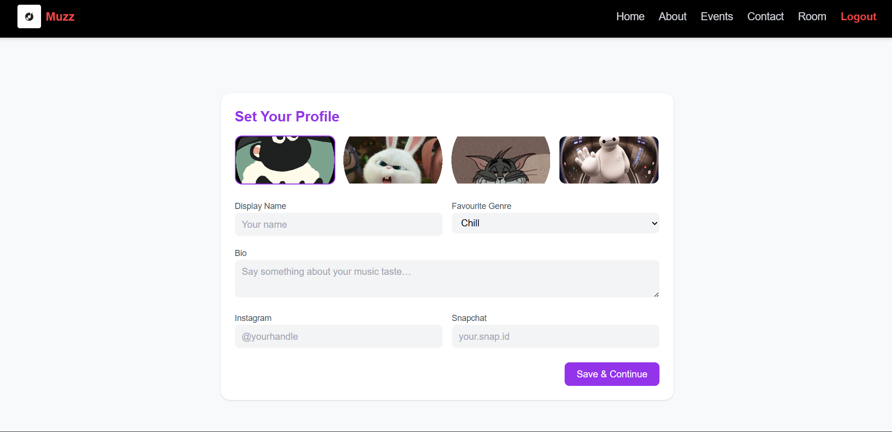

export default Profile;

Conclusion
In this experiment, students successfully learned to build and manage dynamic user profile pages in ReactJS. They gained practical experience in state handling and form management using hooks, rendering and updating UI based on user data, and integrating JSON or API-driven information. The exercise highlighted how personalized features can enhance user engagement and retention, providing a strong foundation for creating interactive and user-centric applications like Muzz.

Experiment 8 : State Management using Context API / Redux in ReactJS
In any modern React-based web application, state management plays a crucial role in maintaining data consistency and ensuring that different parts of the app can access and update shared information smoothly.
In your Music Website, users can:
- Create or join rooms
- Add or remove songs from playlists
- Manage current playback (play/pause/next)
- Share listening sessions with friends
To make all of this work seamlessly across multiple pages, we need a centralized state management system.
This is where Context API or Redux becomes essential.

Objective
The goal of this module is to:
- Manage shared state (like playlist, room details, and active song) globally.
- Enable consistent updates (add/remove/update actions) across all pages.
- Prevent data loss when users navigate between components.
- Build a scalable architecture for future enhancements.
What Is State Management in React?
State in React represents the data that determines how components render and behave.
In simple terms:
State = The “memory” of your app that React tracks and re-renders when it changes.
For small applications, each component can manage its own state using useState.
But when you have multiple components needing access to the same data — like the current playing song or room participants — passing props through many layers becomes inefficient.
That’s when global state management tools like the Context API or Redux are used.

Why State Management Is Important in a Music App
Your app includes various pages such as:
- Home Page (featured playlists)
- Room Page (current songs and users)
- Now Playing Page (currently playing track)
- Profile Page (user preferences)
If each page stored its own state independently, the data wouldn’t sync correctly across pages.
For example:
- The currently playing song might reset when you navigate to a new page.
- The room information could disappear if you refresh the app.
To prevent this, we use a shared global store accessible from any component.

Two Main Approaches

1. React Context API
A built-in React feature — ideal for small to medium-sized apps like your project.
It allows:
- Global state management without extra dependencies.
- Simple setup using createContext and useContext.
Advantages:
- Lightweight and simple.
- Part of React — no need to install Redux.
- Great for managing states like playlist, room info, and current user.
Disadvantages:
- Becomes complex when managing deeply nested state updates.

2. Redux
A powerful external library designed for predictable state management in larger applications.
It uses:
- Store: A single source of truth for all states.
- Actions: Define how state should change.
- Reducers: Logic to handle changes.
- Dispatch: Mechanism to trigger state updates.
Advantages:
- Scalable and predictable.
- Strong debugging tools (Redux DevTools).
- Works well with APIs and asynchronous data.
Disadvantages:
- Slightly more setup than Context API.

Implementing Context API in Your Music App
Let’s adapt it for your app’s needs — where users can add or remove songs from a shared playlist and manage the current playback.

Step 2: Wrap the Entire App with Provider
In App.js:
import React from "react";
import { BrowserRouter as Router, Routes, Route } from "react-router-dom";

import Landing from "./pages/landing"
import Home from "./components/Home";
import About from "./components/About";
import Contact from "./components/Contact";
import Login from "./components/Login";
import Register from "./components/Register";
import Room from "./components/Room";
import Events from "./components/Events";
import Header from "./components/Header";
import Footer from "./components/Footer";

const App = () => {
return (
<Router>
<Header />
<Routes>

<Route path="/" element={<Landing />} />

<Route path="/home" element={<Home />} />

<Route path="/about" element={<About />} />
<Route path="/events" element={<Events />} />
<Route path="/room" element={<Room />} />
<Route path="/contact" element={<Contact />} />

<Route path="/login" element={<Login />} />
<Route path="/register" element={<Register />} />

<Route
path="*"
element={
<div style={{ textAlign: "center", padding: "100px", color: "#fff", background: "#000" }}>
<h2>404 - Page Not Found</h2>
<p>The page you’re looking for doesn’t exist.</p>
</div>
}
/>
</Routes>
<Footer />
</Router>
);
};

export default App;

Step 3: Use Context in Components
Event.jsx
export default function Events() {
const eventList = [
{ title: "DJ Night Party", date: "Nov 19", img: "/event1.jpg" },
{ title: "The Mission", date: "Nov 19", img: "/event2.jpg" },
{ title: "Planet Ibiza", date: "Nov 19", img: "/event3.jpg" },
];

return (
<section className="py-5 bg-dark text-white text-center">
<div className="container">
<h2 className="fw-light mb-5 text-uppercase" style={{ letterSpacing: "2px" }}>
Upcoming Events
</h2>
<div className="row g-4 justify-content-center">
{eventList.map((event, i) => (
<div className="col-md-4 col-sm-10" key={i}>
<div className="card border-0 position-relative overflow-hidden shadow-sm bg-transparent">
<div className="image-container position-relative">
<img
src="https://stories.freepiklabs.com/api/vectors/music-festival/bro/render?color=&background=complete"
className="card-img-top event-img"
alt={event.title}
/>
<div className="image-overlay d-flex flex-column justify-content-end text-start p-3">
<span className="badge bg-danger px-3 py-2 fs-6 align-self-start">
{event.date}
</span>
<h5 className="fw-semibold mt-3 mb-1 text-white">
{event.title}
</h5>
<p className="small text-light mb-0">
Don’t miss the night vibes
</p>
</div>
</div>
</div>
</div>
))}
</div>
</div>
</section>
);
}

Key Functionalities to Manage State
Function | Description | Example
addSong() | Adds a new song to the playlist | User adds a track to shared room
removeSong() | Removes a song by ID | User deletes a song
updateCurrentSong() | Changes current playing song | Auto-plays next track
setRoomUsers() | Tracks users currently in room | Shows who’s listening together

Maintaining State Across Pages
State persistence ensures users don’t lose their current song or playlist when navigating or refreshing the page.

Techniques Used:
- React Context / Redux Store – keeps state global across components.
- localStorage or sessionStorage – stores temporary data in browser memory.
- useEffect Hook – loads saved state on refresh.

Tools and Libraries Used
Tool / Library | Purpose
ReactJS | Component-based UI development
Context API / Redux | Global state management
React Router DOM | Navigation between pages
useState & useContext | Manage and consume shared data
localStorage | Persist data between sessions
Redux Toolkit (Optional) | Simplified Redux state management

Real-World Relevance
In your music listening app, state management ensures:
- Real-time updates — when a song changes in one user’s room, it reflects for everyone.
- Sync between pages — playlist persists even when navigating between Home and Room.
- Scalability — easy to add new features like chat or friend lists without rewriting logic.

OUTPUT :
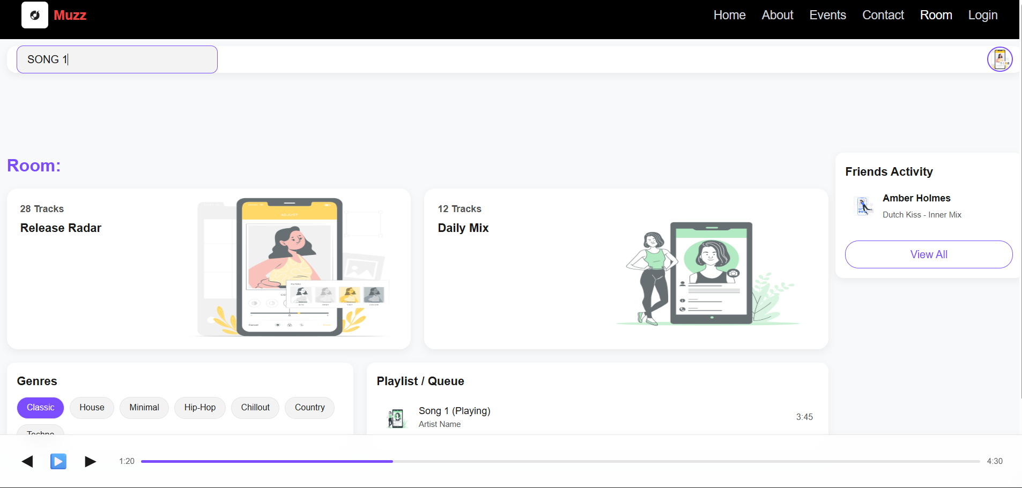
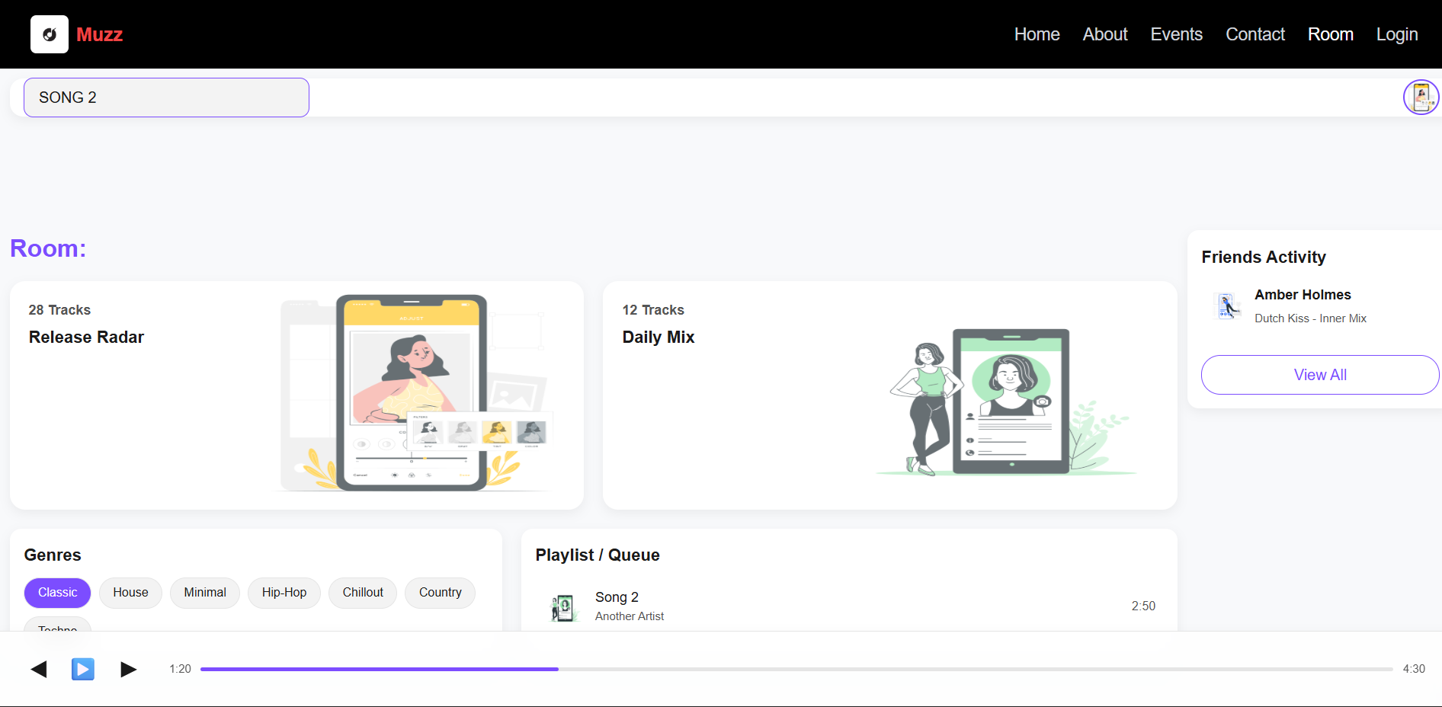
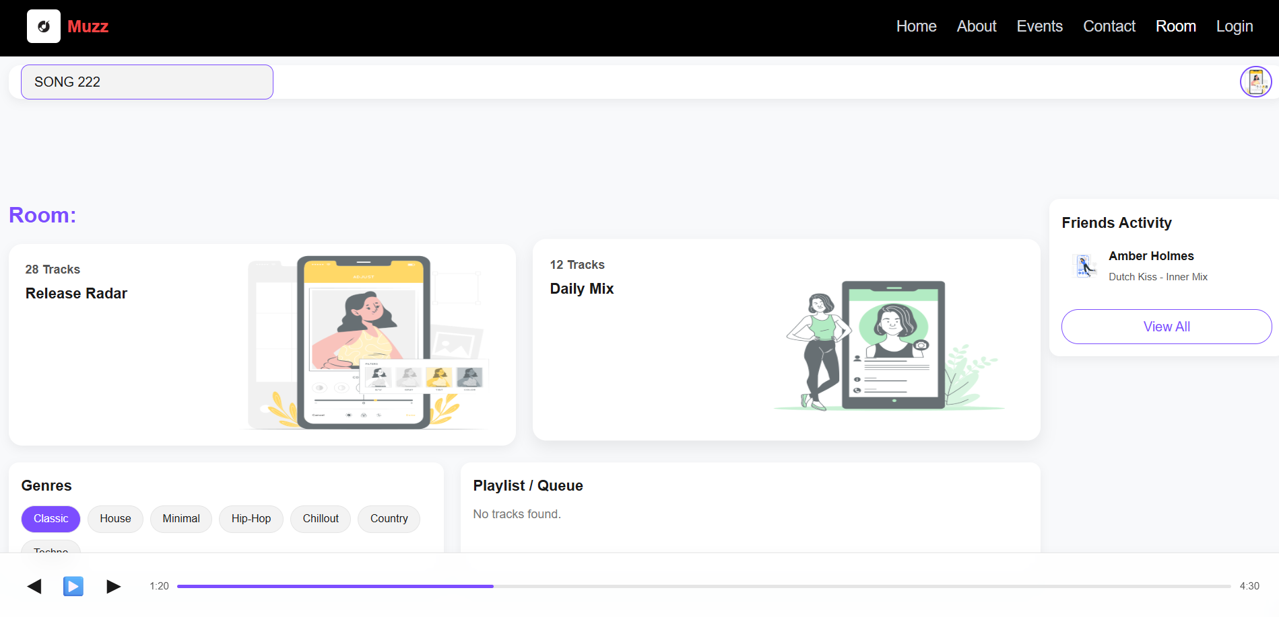

Conclusion
The State Management System is the backbone of your React Music Website.
It ensures smooth coordination, real-time responsiveness, and data consistency across the app.
By implementing Context API or Redux, you achieve:
- Centralized control of shared data (playlist, rooms, users).
- Seamless navigation without data loss.
- A scalable structure for future upgrades.

Experiment 9: Responsive Design Implementation using CSS Flexbox and CSS Grid

1. Introduction
Responsive Design is the process of creating a website that automatically adjusts and looks great on all screen sizes — from large desktop monitors to small mobile screens.
In your Music Website, responsiveness is extremely important because users might access it from phones, tablets, laptops, or PCs while listening to songs or joining music rooms.
A non-responsive layout could cause:
- Buttons or text to appear too small or large
- Music controls (play, pause, volume) to be misplaced
- Room creation or join options to be hidden
Therefore, implementing responsive web design ensures that your music app:
- Looks beautiful on every device
- Provides smooth navigation
- Keeps all interactive elements (player, rooms, buttons) easily accessible
2. Tools and Technologies Used
We will use a combination of CSS Flexbox, CSS Grid, and media queries to achieve a responsive layout.

a. CSS Flexbox (Flexible Box Layout)
Flexbox is a modern CSS layout system that helps align elements horizontally and vertically in a flexible way.

Use Case in Your Music Website:
- Aligning the Navbar items (Home, Rooms, Profile)
- Placing music cards (songs, playlists, rooms) in a responsive row
- Adjusting the layout of Player Controls (Play, Pause, Volume)

b. CSS Grid
CSS Grid is perfect for designing two-dimensional layouts like dashboards, music sections, or room listings.

Use Case in Your Project:
- Arranging music rooms or playlists in grid format.
- Displaying multiple friends or listeners in a room.
- Organizing the Home Page layout with hero banners, trending sections, and player area.

c. CSS Media Queries
Media queries detect the device’s screen width and apply specific styles.
When the screen width is 768px or smaller (like tablets or mobiles):
- The navbar turns into a vertical layout.
- Each music card takes up full width (one per row).

3. Implementation in Your Music Website
Let’s see where responsiveness will be applied in your project:
Page | Responsive Elements | CSS Techniques Used
Home Page | Featured playlists, search bar, music rooms grid | Flexbox, Grid
Room Page | Chat box, active listeners, music player | Flexbox, Media Queries
Profile Page | Profile form, listening history | Grid, Flexbox
Navbar & Footer | Navigation links and social icons | Flexbox, Media Queries

4. Testing Responsiveness
Testing is an important step after styling.

Tools for Testing:
- Chrome DevTools
  - Open DevTools → Click on “Toggle Device Toolbar” (Ctrl + Shift + M)
  - Simulate various screen sizes like iPhone, iPad, Galaxy Fold, etc.
- Responsive Design Mode in Firefox
- Online Tools:
  - Responsinator
  - Am I Responsive
You can use these to test:
- Navbar layout changes
- Player controls alignment
- Visibility of room cards and buttons

5. Benefits of Responsive Design
Benefit | Explanation
Accessibility | Everyone can access your music site easily, regardless of device.
Performance | Optimized layouts load faster on mobile devices.
Consistency | Maintains a uniform user experience across screens.
Better Engagement | Users stay longer when the interface adapts smoothly.
Professionalism | Enhances credibility and usability for modern web standards.

6. Best Practices
- Use relative units like %, em, and rem instead of fixed pixels.
- Keep buttons large enough for mobile tapping (minimum 44x44px).
- Use flex-wrap for wrapping overflowing items in small screens.
- Avoid horizontal scrolling — the layout should fit naturally.
- Optimize images and icons to reduce load time on mobile networks.

7. Real-Life Example in Your Project
Imagine this scenario:
- A user opens the “TuneTogether” Music App on their phone.
- The Home page instantly adjusts to show one music room per row.
- The music player stays fixed at the bottom with large play/pause icons.
- The chat or room members list collapses into a dropdown to save space.
This creates a smooth, enjoyable experience, allowing users to focus on the music rather than struggling with layout issues.
Concept | Description
Flexbox | Aligns and distributes items in one direction (horizontal or vertical).
Grid | Creates 2D layouts for structured page design.
Media Queries | Adapts styles based on device width or height.
Testing Tools | Helps simulate responsiveness on various devices.

CODE:
.event-img {
border-radius: 12px;
transition: transform 0.4s ease, opacity 0.3s ease;
object-fit: cover;
height: 280px;
width: 100%;
background-color: #1e1e1e;
}

.image-container {
border-radius: 12px;
overflow: hidden;
position: relative;
}

.image-overlay {
position: absolute;
inset: 0;
background: linear-gradient(to top, rgba(0, 0, 0, 0.7), transparent);
opacity: 0;
color: white; /* 👈 makes text white */
transition: opacity 0.4s ease, transform 0.3s ease;
}

.image-container:hover .event-img {
transform: scale(1.05);
opacity: 0.9;
}

.image-container:hover .image-overlay {
opacity: 1;
}

.image-overlay h5,
.image-overlay p {
color: white;
}

:root {
--primary-text: #1a1a1a;
--background-color: #f7f7f7;
--accent-black: #000000;
--card-white: #ffffff;
--gray-line: #e0e0e0;
}

* {
box-sizing: border-box;
margin: 0;
padding: 0;
}

body {
font-family: 'Inter', sans-serif;
background-color: var(--background-color);
color: var(--primary-text);
overflow-x: hidden;
}

.landing-container {
max-width: 1400px;
margin: 0 auto;
padding: 0rem 1.5rem;
min-height: 100vh;
position: relative;
overflow: hidden;
}

.navbar {
display: flex;
justify-content: space-between;
align-items: center;
margin-bottom: 4rem;
position: relative;
background-color: transparent;
padding: 0;
}

.logo {
font-size: 1.25rem;
font-weight: 600;
letter-spacing: -0.025em;
margin-top: -1rem;
}

.menu-icon {
font-size: 1.5rem;
cursor: pointer;

line-height: 1;
}

.hero-section {
display: flex;
flex-direction: column;
gap: 3rem;
}

.text-content {
padding-top: 1rem;
}

.text-content h1 {
font-size: 3rem;
font-weight: 800;
line-height: 1.1;
margin-bottom: 2rem;
color: var(--primary-text);
}
.cta-buttons {
display: flex;
align-items: center;
gap: 1.25rem;
margin-top: 1.5rem;
flex-wrap: wrap;
}

.primary-btn {

color: var(--card-white);
padding: 0.5rem 1.5rem;
border-radius: 8px;
border: none;
font-size: 0.875rem;
font-weight: 600;
cursor: pointer;
text-decoration: none;

white-space: nowrap;

}

.primary-btn:hover {
background-color: #222;
transform: translateY(-2px);
}

.secondary-link {
text-decoration: none;
font-size: 0.875rem;
font-weight: 600;
color: #6b7280;
text-transform: uppercase;
transition: color 0.3s;
}

.secondary-link:hover {
color: var(--accent-black);
}

.image-grid {
position: relative;

min-height: 700px;

padding-right: 0;
padding-bottom: 0;
}

.image-grid img {

object-fit: cover;
filter: grayscale(100%);
border-radius: 12px;
box-shadow: 0 5px 10px rgba(0, 0, 0, 0.05);
transition: transform 0.3s, box-shadow 0.3s;
position: absolute;

background-color: var(--card-white);
padding: 8px;
}

.image-grid img:hover, .featured-card:hover {
box-shadow: 0 10px 15px rgba(0, 0, 0, 0.1);
transform: scale(1.01);
}

.img-left {
width: 65%;
max-width: 320px;
height: 300px;
left: 0;
z-index: 10;
}

.img-right {
width: 35%;
max-width: 200px;
height: 400px;
top: 50px;
right: 0;
z-index: 0;
opacity: 0.75;
}

.featured-card {
position: absolute;
width: 90%;
max-width: 380px;
top: 0;
right: 0;
background-color: var(--card-white);
padding: 1.5rem;
border-radius: 12px;
box-shadow: 0 8px 12px rgba(0, 0, 0, 0.1);
z-index: 20;
transition: transform 0.3s, box-shadow 0.3s;
}

.featured-card .img-main {
position: static;
width: 100%;
height: 250px;
margin-bottom: 1.5rem;
border-radius: 8px;
box-shadow: none;
padding: 0;
filter: none;
}

.card-overlay h3 {
font-size: 1.15rem;
font-weight: 700;
margin-bottom: 0.25rem;
}

.card-overlay p {
font-size: 0.75rem;
color: #9ca3af;
}

.card-overlay small {
display: block;
margin-top: 1rem;
font-size: 0.85rem;
color: #6b7280;
}

.scroll-nav {
position: absolute;
bottom: 2rem;
left: 0;
right: 0;
display: none;
align-items: center;
justify-content: space-between;
}

.scroll-nav p {
writing-mode: vertical-rl;
transform: rotate(180deg);
font-size: 0.75rem;
text-transform: uppercase;
color: #9ca3af;
position: absolute;
left: -4rem;
bottom: 0;
}

.prev-next {
display: flex;
gap: 4rem;
font-size: 0.875rem;
color: #9ca3af;
position: absolute;
left: 50%;
transform: translateX(-50%);
}

.prev-next span {
cursor: pointer;
}

.prev-next span:last-child {
color: var(--accent-black);
font-weight: 500;
border-bottom: 1px solid var(--accent-black);
}

@media (min-width: 768px) {
.navbar {
margin-bottom: 6rem;
}
.hero-section {
gap: 4rem;
}
.text-content h1 {
font-size: 4.5rem;
margin-bottom: 3rem;
}
.image-grid {
min-height: 600px;
}
.img-left {
width: 300px;
height: 400px;
top: 120px;
left: 50px;
}
.img-right {
width: 250px;
height: 450px;
top: 50px;
right: -3rem;
}
.featured-card {
width: 420px;
top: 0;
right: 0;
padding: 1.5rem;
}
.featured-card .img-main {
height: 320px;
}
.circle-btn {
top: 345px;
right: 1.5rem;
width: 40px;
height: 40px;
}
}

@media (min-width: 1024px) {
.hero-section {
flex-direction: row;
gap: 6rem;
display: grid;
grid-template-columns: 1fr 1fr;
}

.text-content h1 {
font-size: 6.5rem;
}

.image-grid {
min-height: 650px;
}

.img-left {
width: 320px;
height: 400px;
top: 120px;
left: 0;
}

.img-right {
width: 280px;
height: 500px;
top: 50px;
right: -5rem;
}

.featured-card {
width: 450px;
top: 0;
right: -3rem;
padding: 2rem;
}

.featured-card .img-main {
height: 350px;
}

.circle-btn {
top: 375px;
right: 2rem;
}

.scroll-nav {
display: flex;
}
}

OUTPUT :
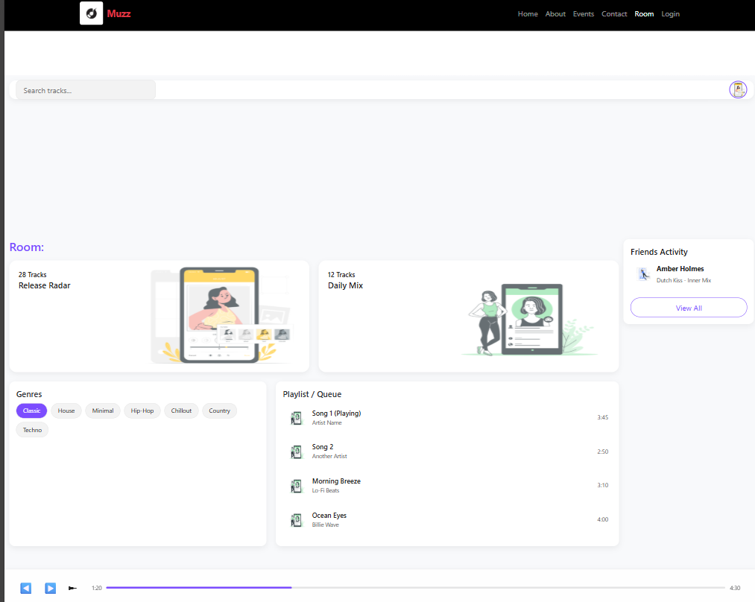

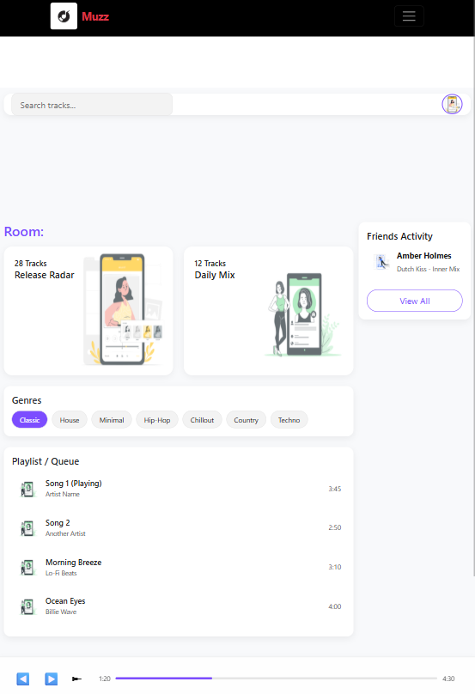

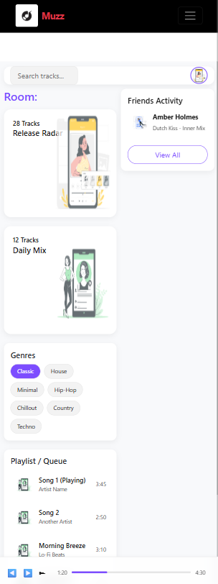
CONCLUSION:
By integrating Flexbox, Grid, and Media Queries, your music website becomes a truly modern, device-independent platform where friends can listen together — anywhere, anytime, and on any screen.
Experiment 10: Final Integration: Build & Submit the Complete Muzz React App

Problem Statement:
In today’s world, music connects people globally, but most existing platforms focus on individual listening experiences.
There is a need for an interactive platform that allows users to listen to music together in real-time, share playlists, and discover or buy tickets for live events — all within one unified application.
This project aims to build a Music Sharing App where users can:
- Create or join music rooms to share and play tracks simultaneously.
- Chat and interact with others in the room.
- Explore upcoming music events and buy tickets directly through the app.

Objective:
- To develop a real-time collaborative platform for sharing and streaming music in virtual rooms.
- To enable users to explore and purchase event tickets through an integrated ticketing module.
- To design an engaging and user-friendly interface that supports interaction and synchronization among multiple users.
- To combine music streaming, community engagement, and event booking into a single, seamless application.

Theory:

1. System Overview
The Music Sharing App integrates two major modules:
- Music Room Module:
Allows users to create or join virtual rooms to listen to the same music simultaneously.
Each room has a host who controls the playback (play, pause, skip).
- Event Module:
Displays upcoming concerts, festivals, and gigs. Users can view event details, buy tickets, and get QR codes for entry.

2. Features
Real-time music streaming using WebSocket or Firebase for synchronization.
Group chat support in each music room.
Event discovery and ticket purchase via integrated API.
User authentication (login/signup).
Dashboard and personalized recommendations based on listening history.

3. Tools and Technologies
- Frontend: React.js / HTML / CSS / JavaScript
- Backend: Node.js / Express.js
- Database: MongoDB or Firebase
- Music API: Spotify API / YouTube Music API
- Event API: Ticketmaster API (or custom event data)
- Hosting: Firebase / Vercel / AWS

4. Workflow of the Application
- User Registration/Login: Users sign up or log in using email or Google authentication.
- Room Creation/Joining:
  - The host creates a music room.
  - Other users join using a code or room ID.
- Real-Time Sync:
  - The app synchronizes playback across all users using WebSocket events.
- Event Discovery:
  - The user browses through a list of upcoming events fetched from the event API.
- Ticket Purchase:
  - The user selects an event, proceeds to payment, and receives a digital ticket (QR code).

Code

Frontend: Create Music Room (React)
export default function Events() {
const eventList = [
{ title: "DJ Night Party", date: "Nov 19", img: "/event1.jpg" },
{ title: "The Mission", date: "Nov 19", img: "/event2.jpg" },
{ title: "Planet Ibiza", date: "Nov 19", img: "/event3.jpg" },
];

return (
<section className="py-5 bg-dark text-white text-center">
<div className="container">
<h2 className="fw-light mb-5 text-uppercase" style={{ letterSpacing: "2px" }}>
Upcoming Events
</h2>
<div className="row g-4 justify-content-center">
{eventList.map((event, i) => (
<div className="col-md-4 col-sm-10" key={i}>
<div className="card border-0 position-relative overflow-hidden shadow-sm bg-transparent">
<div className="image-container position-relative">
<img
src="https://stories.freepiklabs.com/api/vectors/music-festival/bro/render?color=&background=complete"
className="card-img-top event-img"
alt={event.title}
/>
<div className="image-overlay d-flex flex-column justify-content-end text-start p-3">
<span className="badge bg-danger px-3 py-2 fs-6 align-self-start">
{event.date}
</span>
<h5 className="fw-semibold mt-3 mb-1 text-white">
{event.title}
</h5>
<p className="small text-light mb-0">
Don’t miss the night vibes
</p>
</div>
</div>
</div>
</div>
))}
</div>
</div>
</section>
);
}
Room.jsx
import { useParams } from "react-router-dom";
import { useState } from "react";
import "./Room.css";

export default function Room() {
const { id } = useParams();

const [searchQuery, setSearchQuery] = useState("");
const [isPlaying, setIsPlaying] = useState(false);

const tracks = [
{ title: "Song 1 (Playing)", artist: "Artist Name", duration: "3:45" },
{ title: "Song 2", artist: "Another Artist", duration: "2:50" },
{ title: "Morning Breeze", artist: "Lo-Fi Beats", duration: "3:10" },
{ title: "Ocean Eyes", artist: "Billie Wave", duration: "4:00" },
];

const filteredTracks = tracks.filter(
(track) =>
track.title.toLowerCase().includes(searchQuery.toLowerCase()) ||
track.artist.toLowerCase().includes(searchQuery.toLowerCase())
);

const togglePlayPause = () => {
setIsPlaying((prev) => !prev);
};

return (
<div className="room-page-container">
<div className="main-app-container">

<div className="top-navbar">
<input
type="text"
placeholder="Search tracks..."
className="search-input"
value={searchQuery}
onChange={(e) => setSearchQuery(e.target.value)}
/>
<div>
<img
src="https://stories.freepiklabs.com/api/vectors/edit-photo/cuate/render?color=&background=complete"
alt="Profile"
className="user-profile"
/>
</div>
</div>

<div className="player-content-area">
<h2 className="room-header">Room: {id}</h2>

<div className="music-card-grid">
<div className="music-card card-purple">
<p className="card-title">28 Tracks</p>
<h4 className="card-subtitle">Release Radar</h4>
<img
src="https://stories.freepiklabs.com/api/vectors/edit-photo/cuate/render?color=&background=complete"
alt="User"
className="card-image-overlay"
/>
</div>
<div className="music-card card-cyan">
<p className="card-title">12 Tracks</p>
<h4 className="card-subtitle">Daily Mix</h4>
<img
src="https://stories.freepiklabs.com/api/vectors/profile-pic/bro/render?color=&background=complete&hide="
alt="User"
className="card-image-overlay"
/>
</div>
</div>

<div className="genres-and-tracks">
<div className="genre-panel">
<h4 className="panel-title">Genres</h4>
<div className="genre-button-grid">
<button className="genre-btn active">Classic</button>
<button className="genre-btn">House</button>
<button className="genre-btn">Minimal</button>
<button className="genre-btn">Hip-Hop</button>
<button className="genre-btn">Chillout</button>
<button className="genre-btn">Country</button>
<button className="genre-btn">Techno</button>
</div>
</div>

<div className="tracks-panel">
<h4 className="panel-title">Playlist / Queue</h4>
<ul className="list-group">
{filteredTracks.length > 0 ? (
filteredTracks.map((track, index) => (
<li className="track-list-item" key={index}>
<img
src="https://stories.freepiklabs.com/api/vectors/profile-pic/bro/render?color=&background=complete&hide="
alt="Art"
className="track-album-art"
/>
<div className="track-info">
<div className="track-details">{track.title}</div>
<div className="track-artist">{track.artist}</div>
</div>
<span className="track-duration">{track.duration}</span>
</li>
))
) : (
<p style={{ fontSize: "0.9rem", color: "#777" }}>
No tracks found.
</p>
)}
</ul>
</div>
</div>
</div>

<div className="friends-panel">
<h4 className="panel-title">Friends Activity</h4>
<div className="friend-item">
<img
src="https://stories.freepiklabs.com/api/vectors/profile-pic/rafiki/render?color=&background=complete&hide="
alt="Friend"
className="friend-avatar"
/>
<div className="friend-details">
<strong>Amber Holmes</strong>
<small>Dutch Kiss - Inner Mix</small>
</div>
</div>
<button className="view-all-btn">View All</button>
</div>
</div>

<div className="shared-player-bar">
<div className="player-controls">
<button>&#9664;</button>
<button onClick={togglePlayPause}>
{isPlaying ? "⏸️" : "▶️"}
</button>
<button>&#9658;</button>
</div>
<div className="player-progress-bar">
<span>1:20</span>
<div className="progress-line">
<div className="progress-filled"></div>
</div>
<span>4:30</span>
</div>
</div>
</div>
);
}

OUTPUT :
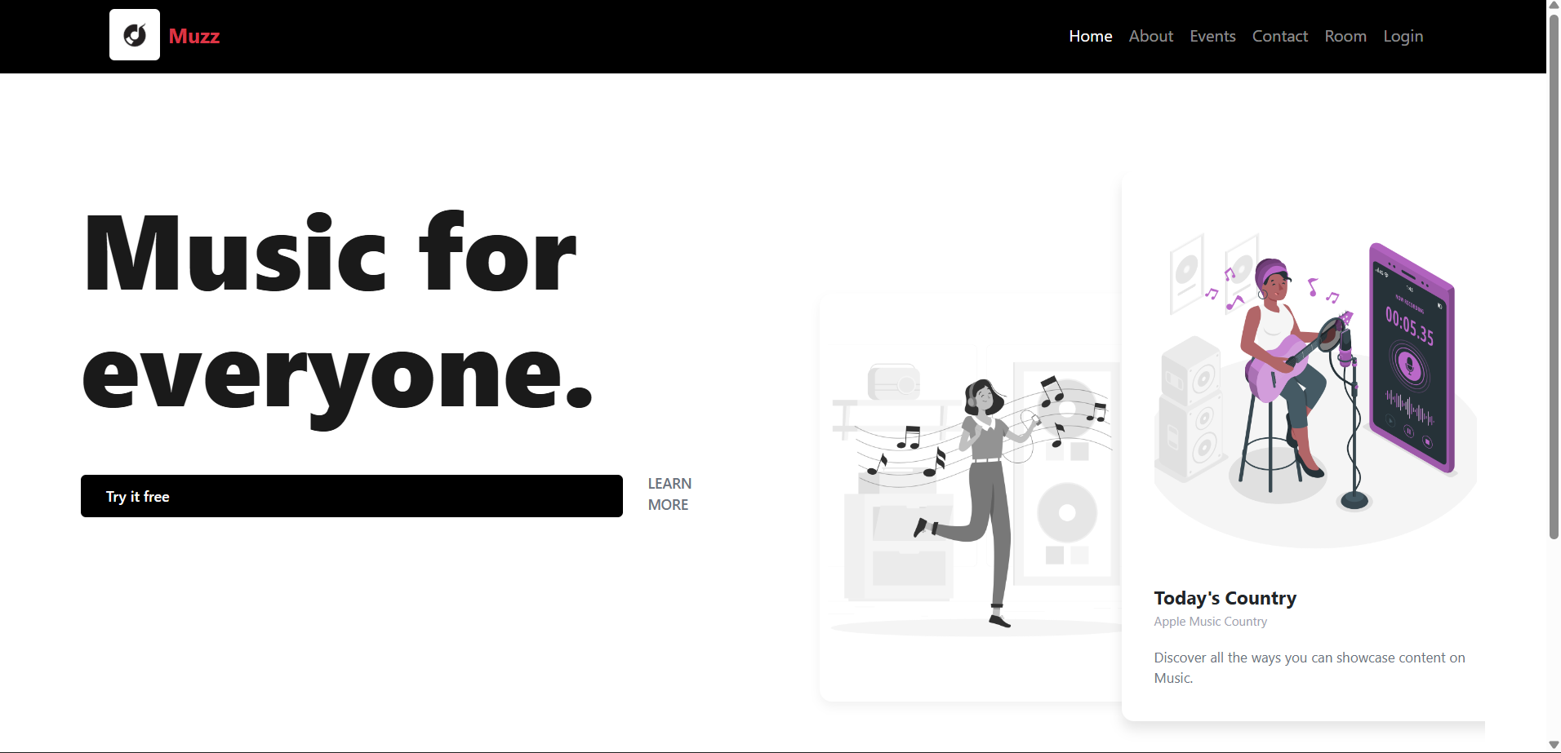
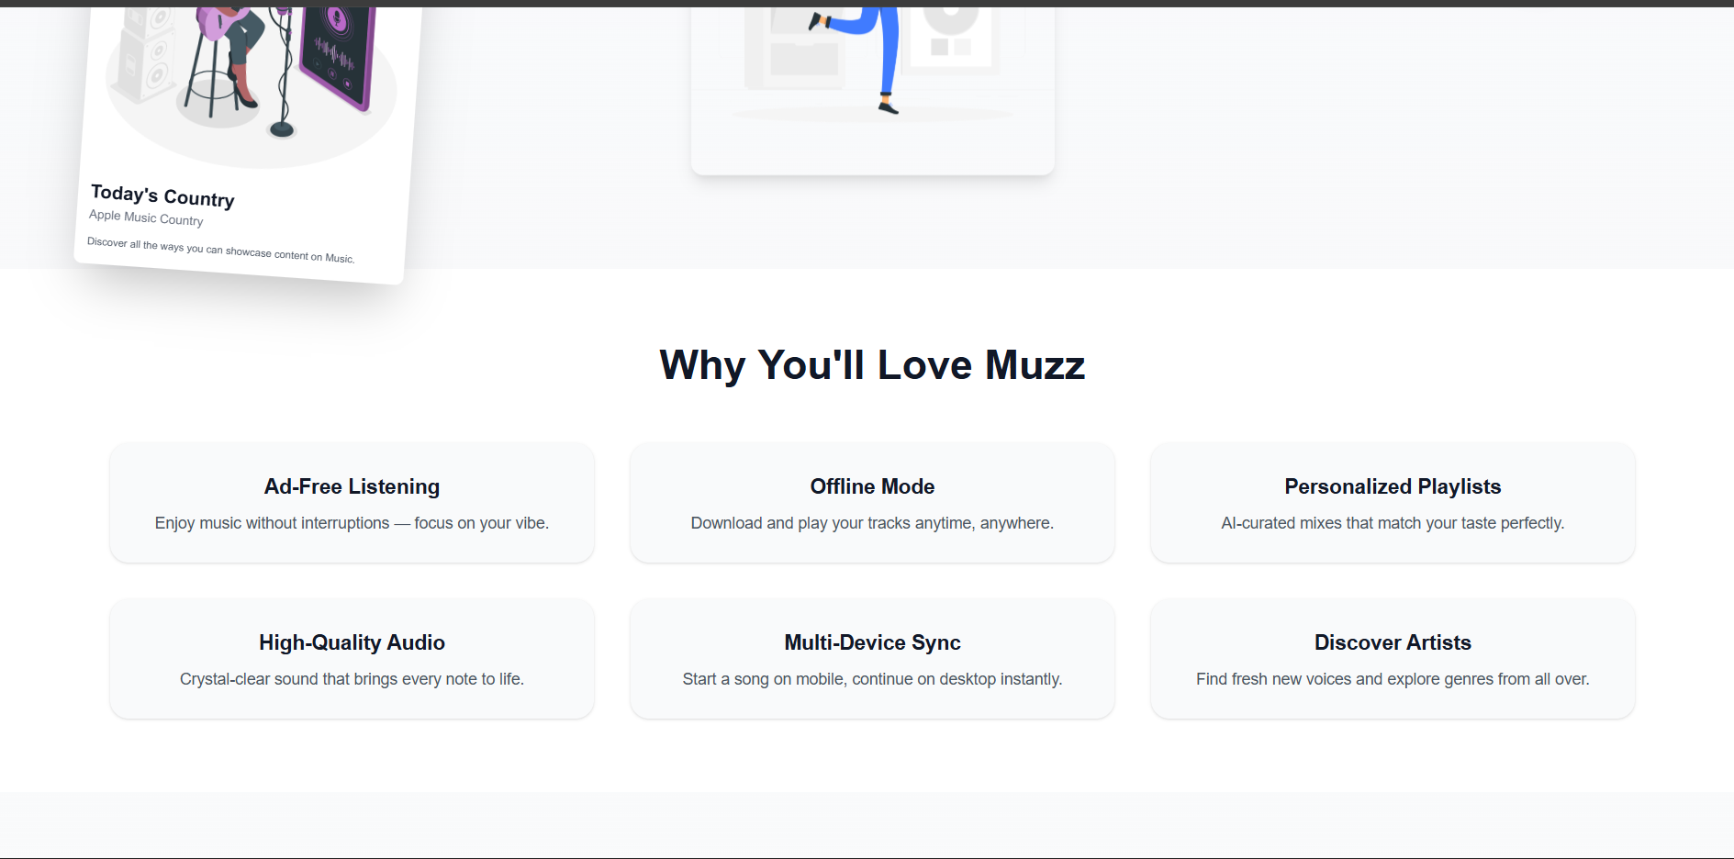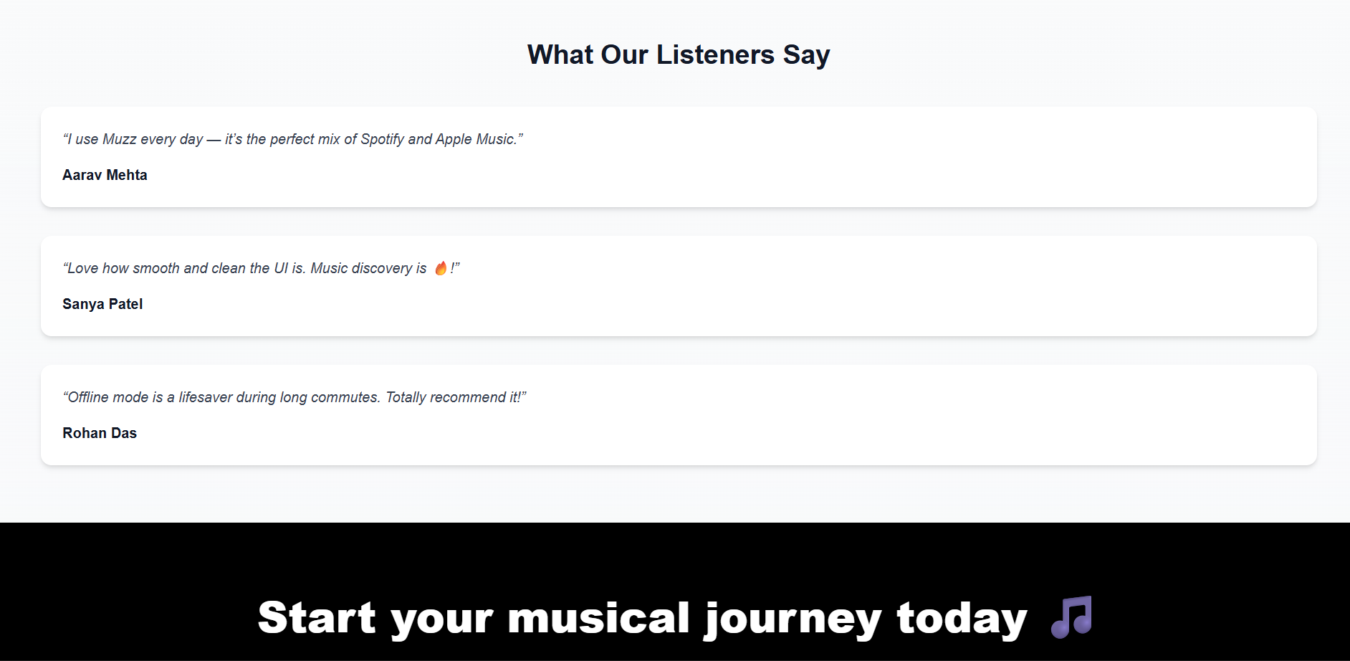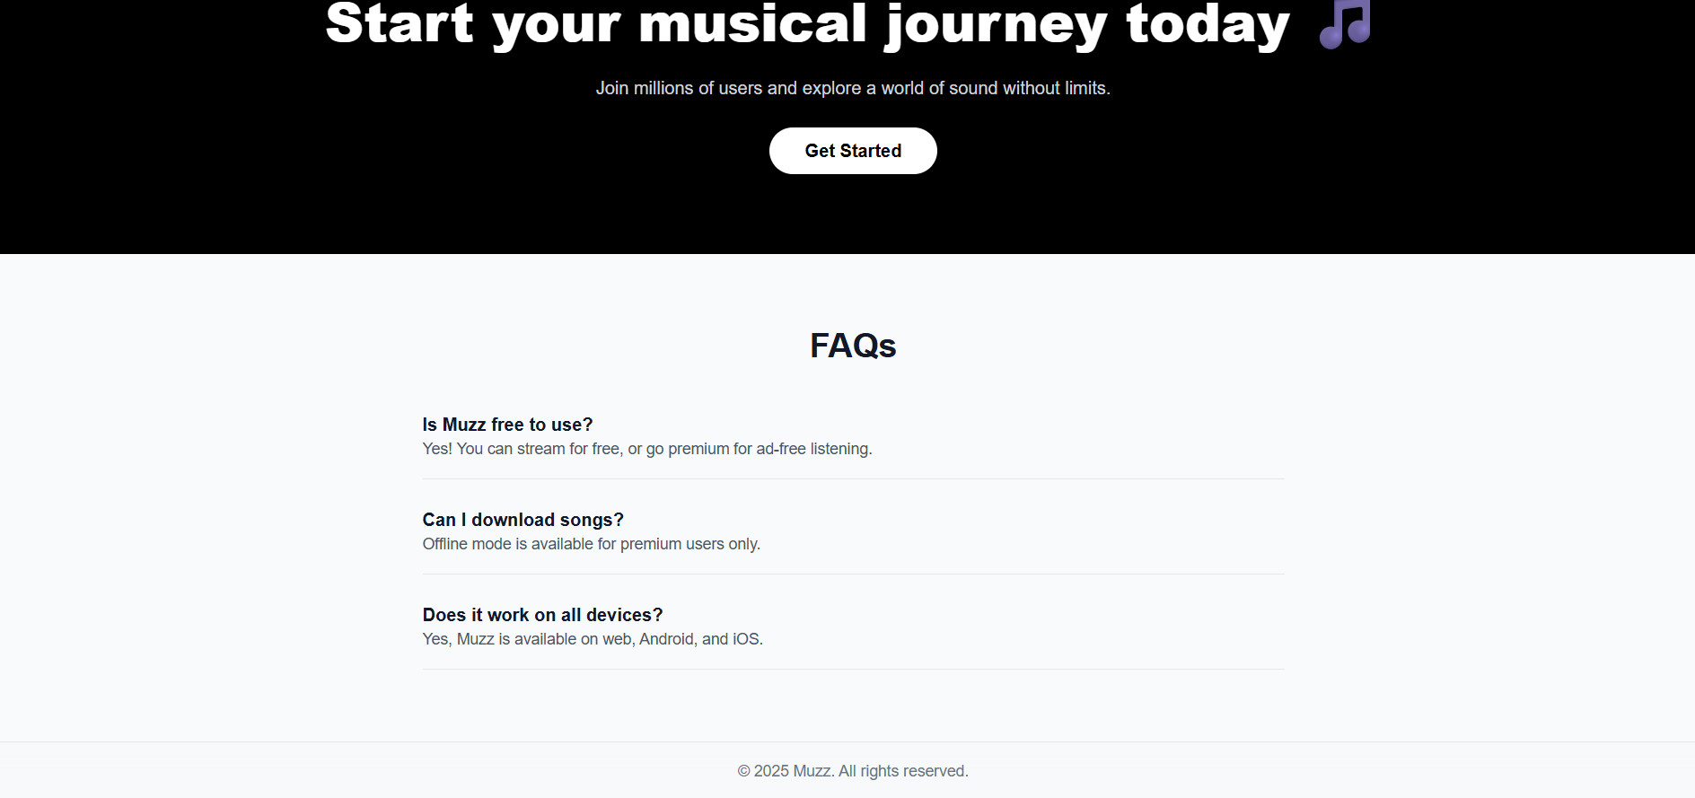

Conclusion:
The Music Sharing and Event Ticketing App successfully demonstrates how technology can create shared musical experiences while integrating entertainment and convenience.
Through this project, users can connect in real-time, listen to the same tracks together, and explore or purchase tickets for live music events seamlessly.
This system combines the power of real-time synchronization, API integration, and user engagement, making it both socially interactive and commercially viable.
In conclusion, the project bridges the gap between virtual music enjoyment and real-world event participation, offering users an innovative and connected music experience.

